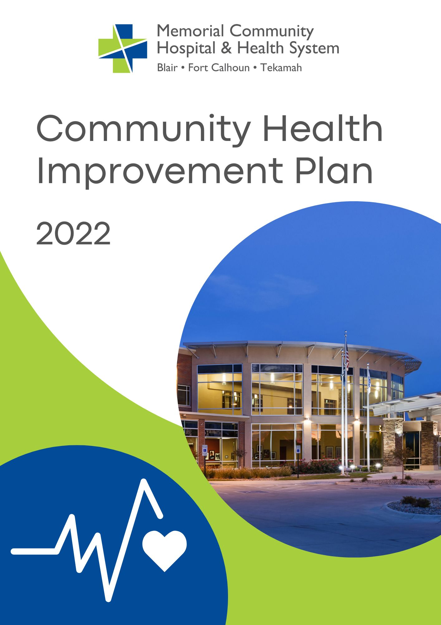
Contents

Executive Summary 2
Acknowledgements 3
Memorial Community Hospital and Health System Overview 4
Demographic Characteristics 6
Community Health Improvement Process 9
CHA/CHIP Timeline 10
CHIP Implementation Process 10
Washington County CHIP 11

Executive Summary

We are pleased to present the 2022 Washington County Community Health Improvement Plan (CHIP). The purpose and goal of is to identify how to strategically and collaboratively address community priority areas to improve the health and well-being of the community. Employees from Memorial Community Hospital and Health System (MCH) utilized the assessment process to formulate a community health improvement plan striving to provide effective, quality health services, and an environment that enables community members to reach their full health potential through assessment, leadership, and partnerships.

MCH’s mission is to Partner with the Community to Heal, Nurture and Promote Wellness. The community is defined as residents in Washington and Burt County in eastern Nebraska though we pull patients from the surrounding counties of Harrison, Douglas, and Dodge as well. The information and figures below highlight the demographics of Washington County, Three Rivers Public Health District (3RPHD), and the State of Nebraska. It is important to note that our service area includes Burt County, but for the purpose of this plan, the data from our main service area was utilized.

With input from stakeholders and partner organizations, our community prioritized the following strategic issues to be the focus of our collaborative efforts over the next three years. Most specifically at MCH, Behavioral Health and Unhealthy Lifestyles/Obesity will be considered top priorities.

Washington County
Issue 1 | Behavioral Health
Issue 2 | Access to Healthcare
Issue 3 | Senior Wellbeing
Issue 4 | Youth Wellbeing
Issue 5 | Lack of Awareness & Affordable Wellness Opportunities
Issue 6 | Obesity

This plan provides the rationale for which strategic issues were prioritized and the goals, strategies, resources, and performance measures that MCH will utilize to help improve the health of our community.

This plan is also meant as a tool for our community organizations to help guide the work they are doing. Although our community organizations may use different strategies to address these health issues the community will be working towards the same goals. Through collaboration and evidence-based practices we will strive to improve the health of all who live, work, and play in our service area.

Progress updates and additional resource information will be added to this plan and published to the MCH webpage (www.mchhs.org).

Background data for each priority area can be found in the Washington County/Three Rivers Public Health Department Community Health Assessment, available on the MCH website at www.mchhs.org.

Acknowledgements

Every three years, Three River Public Health Department (3RPHD) in collaboration with partners Methodist Fremont Health, Memorial Community Hospital & Health System, and Saunders Medical Center completes a Community Health Assessment (CHA) which then informs a Community Health Improvement Plan (CHIP) for Dodge, Washington, and Saunders counties in eastern Nebraska. This project was made possible through grant funding from the State of Nebraska Department of Health and Human Services, Division of Public Health, Office of Community Health.

To start the assessment process 3RPHD formed a CHA/CHIP Steering Committee to help guide the process. The committee included members from each county served by 3RPHD and each of the collaborating hospitals. We would like to thank all the CHA/CHIP Steering Committee members for their hard work and guidance.

Steering Committee Members
Jill Gossett- Methodist Fremont Health
Shawn Shanahan- Methodist Fremont Health
Laura Willey- Memorial Community Hospital
Stacie Sabatka- Saunders Medical Center
Scott Jensen- Fremont Public Schools
Kristen Fagan- Dodge County Head Start
Dan Douglas- Washington County- Emergency Management Agency
Bob Reynolds- Dodge County Sheriff
Amber Pelan- Saunders County Youth Services
Theresa Klein- Wahoo Chamber of Commerce
Michelle Padilla- Fremont Family Coalition
Rossana Jaeger- Fremont Family Coalition
Terra Uhing- Three Rivers Public Health Department
Greg Moser- Three Rivers Public Health Department
Evelyn Martinez- Three Rivers Public Health Department

In addition, 3RPHD deployed an online Community Health Survey. A survey with various health related questions was administered to individuals who live and work in Dodge, Washington, and Saunders counties to learn what community members saw as the most important health issues to address. The CHA/CHIP process was made possible through subaward funding from the State of Nebraska Department of Health and Human Services, Division of Public Health, Office of Community Health. Memorial Community Hospital & Health System also provided $600 in gift cards as incentive for individuals to complete the survey.

We would like to thank Makayla Schissel, Data Analyst who assembled the CHA and presented the data at each of the community CHIP meetings and Lynne Lange with Mission Matters who facilitated each of the community CHIP meetings.

Memorial Community Hospital and Health System Overview

Our Mission:
To Partner with the Community to Heal, Nurture, and Promote Wellness.

Our Vision:
Memorial Community Hospital and Health System’s Vision is to provide the highest quality of healthcare and to be the first choice in the communities we serve.

Memorial Community Hospital (MCH) is a full-service, 17 acute-care bed community hospital, located in Blair, Nebraska. Three Rural Health Clinics also comprise the health system, one in Blair, Fort Calhoun, and Tekamah and a Specialty Clinic in Blair with services such as Cardiology, ENT, General Surgery, Orthopedics, Oncology, Pulmonology, Rheumatology, Urology and Vascular. The hospital employs 11 physicians, 10 physician assistants, four nurse practitioners, and two CRNA’s. It also contracts with 3 orthopedic surgeons and a general surgeon. MCH is a 501(c)3 not-for-profit organization and provides care for those primarily living in Burt and Washington Counties in Eastern Nebraska. MCH is located along the Missouri River approximately 20 miles north from the metropolitan area of Omaha, Nebraska.

MCH also provides the following services:
- Labor and Delivery Beds/Obstetric Care
- 24-hour emergency care with heliport accommodations
- Diagnostic imaging services: MRI, CT, Dexa bone density scans, Nuclear Medicine, general radiology, mammography, surgical radiography, fluoroscopy, PET scan and ultrasound
- Diagnostic and evaluative laboratory services
- Cardiovascular services including non-invasive diagnostics studies such as EKG, telemetry monitoring, treadmill stress testing, ECHO cardiogram and stress ECHO cardiogram
- Cardiac and Pulmonary Rehabilitation
- Inpatient and outpatient Physical and Occupational Therapy
- Nutritional services
- Outpatient surgery
- Outpatient clinics
- Orthopedic surgery
- Respite services
- Skilled nursing services
- Social services
- Educational programs and instruction for patients, staff and the community

Leadership of Memorial Community Hospital and Health System
MCH Leadership | TITLE
Manny Wolf | President/Chief Executive Officer
Amy Zimmer | Vice President of Patient Care Services
Jen Newby | Operations Director of Support Services/Finance
Keala Roy | Operations Director of Nursing and Emergency Management Coordinator
Kris Nielsen | Operations Director Human Resources
Tim Schnack | Chief Financial Officer

Board members of Memorial Community Hospital and Health System

The MCH Hospital Board is made up of four community members representing 60% of the hospital ownership and three members from CHI, representing a 40% ownership role. A supermajority is needed to pass any vote.

BOARD MEMBERS | ROLE
Kyle Acre | Board Chair
Dr. Gregg Drabek | Vice Chair/CHI Board Member
Sarah Chatt | Treasurer
Neil Smith | Secretary
Dr. Sandra Baumberger | MCH Board Member
Robin Conyers | CHI Board Member
Lori Nahnsen | CHI Board Member

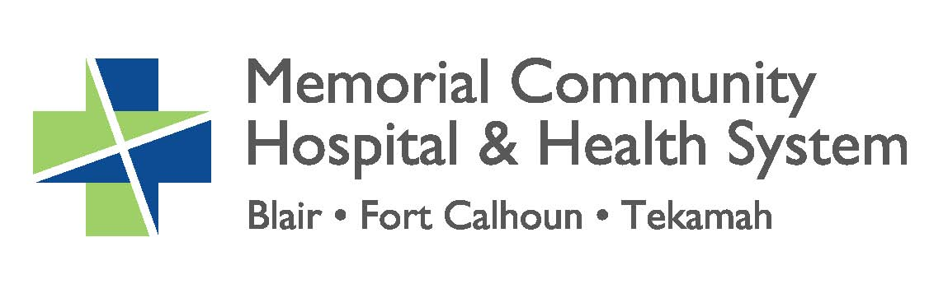

402-426-2182
www.mchhs.org
810 N 22nd St, Blair, NE

Demographic Characteristics

Overview
Population (2020 estimate)ª | 78,467 (State: 1,961,504)
Population Change (2010-2021) ^{b} | 5.2% (State: 7.3%)
Persons in Poverty (2020) ª | 8.3% (State: 10.4%)
Rural Population ^{c} | 45.1% (State: 25.5%)
Minority Populationª | 9.3% (State: 21.7%)
Total Land Area ^{d} | 1,667.96 sq. miles (State: 76,817.87 sq. miles)
ª: U.S. Census/American Community Survey 5-Year Estimates (2020).
^{b.} www.usafacts.org (2022)
^{c}. Census Population Estimates (2010).
^{d.} www.census.gov/quickfacts (2022)

Figure 1: Location of Three Rivers District, Counties, Cities, Rural Health Clinics and Hospitals
Sources: TIGER/Line Shapefiles - Census Bureau. Nebraska Department of Health and Human Services (location of hospitals and rural health clinics), 2018
Total population of Washington County is 20,667 (Figure 2).

Figure 2: Population (2020)
Washington County | Three Rivers
20,546 | 78,467
Source: U.S. Census/American Community Survey 5-Year Estimates (2020). Table DP05.

As a whole, the Three Rivers District is 90.7% White, non-Hispanic. There are 5.8% people of a minority population in Washington County (Figure 3).

Figure 3: Race/Ethnicity (2020)
 | Washington County | Three Rivers Total | Nebraska
White  (non-Hispanic) | 94.2% | 90.7% | 78.3%
Minority | 5.8% | 9.3% | 21.7%
Source: U.S. Census/American Community Survey 5-Year Estimates (2020). Table DP05.

Washington County has a median age of 40.9, which is 4.3 years older when compared to the median age for the State (Figure 4).

Figure 4: Median age (2017)
Washington County | Three Rivers* | Nebraska
40.9 | 40.4 | 36.6
*An average weighted by the population in each county. Source: U.S. Census/American Community Survey 5-Year Estimates (2020). Table DP05

Among the three counties in the Three Rivers District, Washington County has the lowest percentage (18.0%) of the 65 or older population. As a whole, 18.7% of the Three Rivers District is 65 or older (compared to 15.7% for the State) (Figure 5).

Figure 5: Number and percentage of the 65 and over population (2020)
Washington County | Three Rivers | Nebraska
3,704  (18.0%) | 14,651  (18.7%) | 302,031  (15.7%)
Source: U.S. Census/American Community Survey 5-Year Estimates (2020)

Just under one-fourth (24.4%) of the Washington County population is under the age of 18 (Figure 6).

Figure 6: Number and percentage of the under 18 population (2020)
Washington County | Three Rivers | Nebraska
5,017  (24.4%) | 19,043  (24.3%) | 475,103  (24.7%)
Source: U.S. Census/American Community Survey 5-Year Estimates (2020)

From 2013 to 2017, the birth rate was lower for Washington County than it was for the State. For 2013-2017 years combined, there were 1,107 births in the county, which makes for a rate of 10.9 births per 1,000 population (compared to a rate of 13.9 per 1,000 population for the State) (Figure 7).

Figure 7. Number of births and birth rate per 1,000 population
Washington County | 1,107 (10.9)
Three Rivers | 4,801 (12.4)
Nebraska | 131,993 (13.9)
Source: Nebraska DHHS, Vital Records (2019)

Washington County stands out as having a notably higher median household income and per capita income as compared to the State. (Figure 8).

Figure 8: Income (2020)
 | Washington County | Three Rivers* | Nebraska
Median household income | $71,505 | $66,789 | $63,015
Per capita income | $36,834 | $33,661 | $33,205
*An average weighted by the population in each county. Source: U.S. Census/American Community Survey 5-Year Estimates (2020). Tables S1901 & DP03

According to the 2010 Census data, 60.3% of the population in Washington County lives in a rural area, compared to 25.5% for Nebraska. Figure 9.

Figure 9: Number and percentage of rural population (2010)
 | Population | # Rural | % Rural
Washington County | 20,546 | 12,390 | 60.3%
Three Rivers | 78,467 | 35,426 | 45.1%
Nebraska | 1,923,826 | 490,655 | 25.5%
Source: Census Population Estimates (2010). Table PCT2

Community Health Improvement Process

Improving community health is a task that cannot be accomplished by any one organization alone. The purpose of the CHIP is to identify how to strategically and collaboratively address community priority issues to improve the health and well-being of the community. The CHIP provides a blueprint for how organizations can look beyond their individual work and priorities to collaborate on addressing the health issues that were mutually agreed upon.

There are many benefits to having a collaborative CHIP including:
- Collective impact to improve community health
- Sharing of best practices, lessons learned, and successes
- Efficient use of resources
- Increased awareness of the efforts and programs in the community

Steps of the CHIP Process

1. A CHA/CHIP Steering Committee was formed to help guide the CHIP process. The committee included members from each county served by 3RPHD and each of the collaborating hospitals.

2. Data on many different health issues and socioeconomic factors are compiled for the CHA using a variety of local, state, and national data sources.

3. To better understand the health perspectives of those who live the in the 3RPHD District, four assessments were administered throughout the three counties.

4. A community meeting was held in each county where the CHA data was presented, and a facilitated discussion was held to identify priority health needs to be addressed over the next three years.

5. The prioritized health issues for each county are included in the 3RPHD CHIP along with specific objectives and strategies for addressing the prioritized health issues.

6. The CHIP for Washington County was developed by hosting meetings with MCH employees and inviting community members. MCH utilized the 3RPHD’s CHIP to create their own while adding additional initiatives specific to MCH.
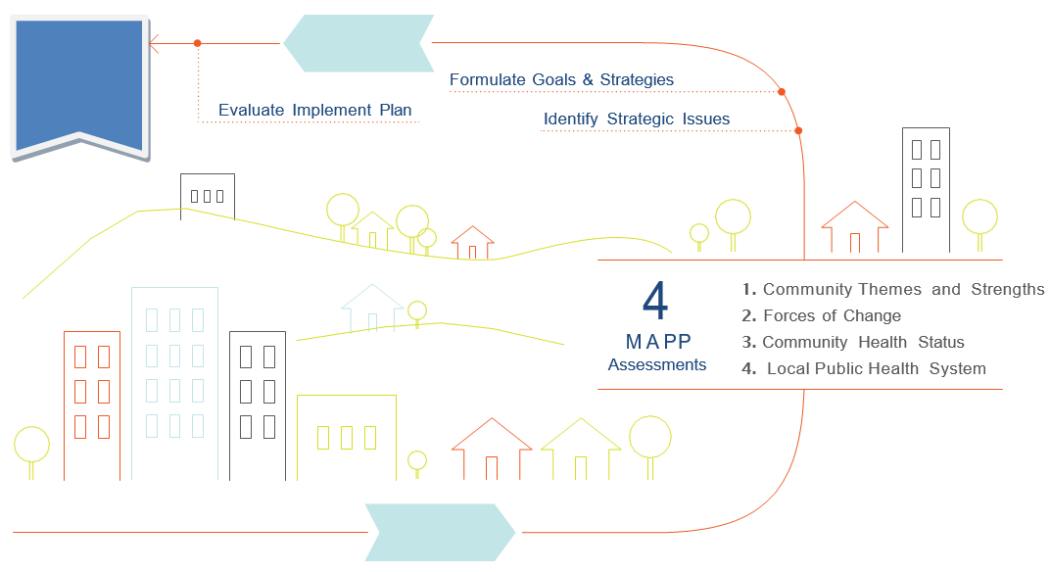
A Healthier Community!
Action Cycle

Vision

CHA/CHIP Timeline

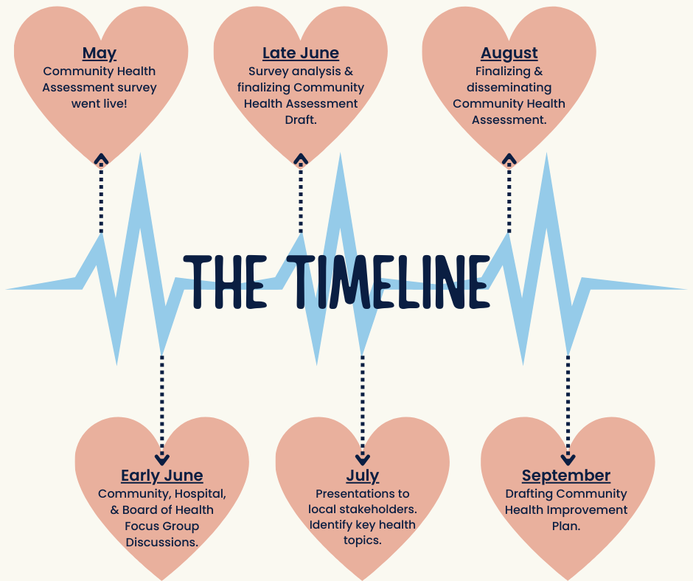

CHIP Implementation Process

The CHIP will be conducted over the next three years, from January 2023 to December
2025. It will be jointly implemented through collaboration between MCH, public health, schools, and community organizations in the Washington County service area.

The COVID-19 pandemic showed us there are myriad opportunities to strengthen our public health system. With these opportunities come challenges due to various socioeconomic factors. To take advantage of opportunities and face these challenges, 3RPHD and MCH will need to collaborate with partners and stakeholders to ensure the plan is successful.

To address the health issues strategically, MCH selected two health topics to focus on. The strategies utilized in the plan to address each health topic will be monitored quarterly to ensure progress is being made and to determine if quality improvement initiatives are needed to achieve success. While this plan illustrates the choice of a couple key priorities, it is recognized that there are other health issues to address in subsequent years, many current efforts already occurring, and ongoing opportunities to partner for optimal success.

The following sections illustrate the health topics that were prioritized in Washington County.

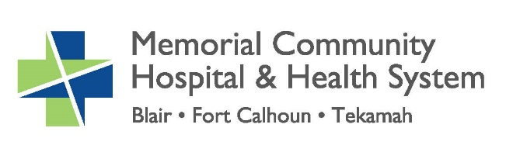

Washington County
Community Health Improvement Plan
2023-2025

Issue 1: Behavioral Health

Objective 1: Memorial Community Hospital will reduce the stigma of seeking help for behavioral health issues in Washington County.

Strategies | Measures
Partner with Three Rivers Public Health to share consistent messaging focused on behavioral health as a part of overall health.  Implement a public awareness campaign educating the community about behavioral health as a medical condition.  Educate the community about confidential behavioral health services in the area.  Educate the community about the behavioral and mental health resources for our seniors.  Monitor behavioral and mental health of health care workers. | Increased awareness of behavioral health services through marketing and social media.  Number of stakeholders reached with the public awareness campaign.  Share information on the MCH Behavioral Health section of the MCH website.  Number of outreach activities and marketing campaigns for Senior Life Solutions.  Measure how often Dayforce health screening is used among staff. Educate staff on EAP.
Time Frame | Organization(s) and departments responsible
January 2023-December 2025 | 3RPHD, MCH Leadership, MCH Marketing, Senior Life Solutions, MCH HR
Results

Objective 2: Memorial Community Hospital will increase access of behavioral health services being offered in the community and reduce barriers for individuals to access current mental health services.

Strategies | Measures
Coordinate efforts with Lutheran Family Services’ (LFS) Crisis Mobile Response in the ER for Behavioral Health patients who need additional assistance.  Research and implement an Integrated Primary Health Model in the Blair Clinic for behavioral health.  Increase the use of the PHQ Depression Screening tool for patients of eligible age (over age 12) in the MCH Clinics. | Increase the number of referrals to LFS over 2022.  Determine the feasibility and advantage of having an employed vs. contracted mental health provider.  Implement first steps by December 2023.  Increase number of patients being screened for depression from 55% to 71.4% by using the PHQ screening tool.  Refer and track all patients who test positive.
Time Frame | Organization(s) and departments responsible
January 2023-December 2025 | MCH&HS, MCH Clinics, MCH ED
Results

Issue 2: Unhealthy Lifestyles/Obesity

Objective 1: Memorial Community Hospital and Health System will promote healthy living for all individuals and those with a chronic health condition in Washington County.

Strategies | Measures
Promote healthy living through our Medicare Wellness Visit programs through the Accountable Care Organization.  Share success stories of those that improve their health through the Medicare Wellness Visit.  Track percentage of patients 18 to 75 years of age and part of the Diabetes Registry, whose most recent hemoglobin A1c (HbA1c) was greater than 9.0% or HbA1c not completed in the last 12 months. | Increase participants with Medicare Wellness Visits over 2022 numbers.  Success stories documented on MCH Facebook and in the newsletter.  Goal is to have 80% of patients in compliance.  Refer and track patients who need assistance in meeting the goal to Dietician and Endocrinologist.
Time Frame | Organization(s) and departments responsible
January 2023-December 2025 | MCH Clinics, MCH Marketing
Results

Objective 2: Memorial Community Hospital will implement prevention strategies to educate patients and the community on obesity reduction measures.

Strategies | Measures
Promote healthy eating education through the ACO Medicare Wellness Visit program.  Increase MCH Physician referrals to weight management program.  Coordinate MCH Dietician outreach activities around healthy eating for community groups.  Sponsor healthy activities and initiatives in the community and through the schools. | Track number of participants in the Medicare wellness visit program and those receiving healthy eating education. Increase participants over 2022 numbers.  Advertise MCH Dietician services.  Track and increase referrals of current patients to weight management program.  Coordinate Dietician outreach activities with the goal of one event per year.  Research viability and continue to be involved with the Dana Campus community discussions around food insecurity.  Track number of sponsorships and participation in health focused community activities.
Time Frame | Organization(s) and departments responsible
January 2023-December 2025 | MCH Clinics, MCH Dietician, MCH Marketing
Results

