Hope’s Arrival Amidst Challenging Times
In the midst of a time of uncertainty and perhaps a little fear of what lies ahead over the next months, a little bit of hope shined brightly in the Labor and Delivery department at Memorial Community Hospital and Health System (MCH&HS). Meet Hope Eliza Boeckman, born at MCH&HS on Friday, March 20th. Weighing just a little over seven pounds, this little one brought a whole lot of joy---and hope---to her family and MCH&HS staff during a somewhat gloomy time as news of COVID-19 continues to spread nationwide.
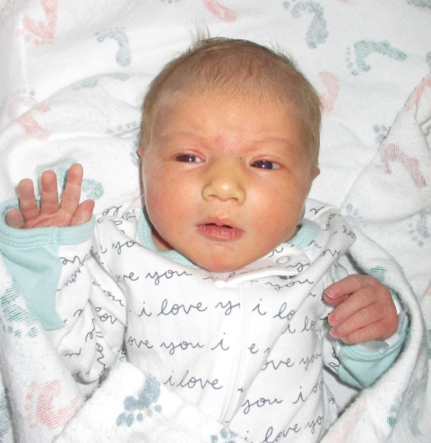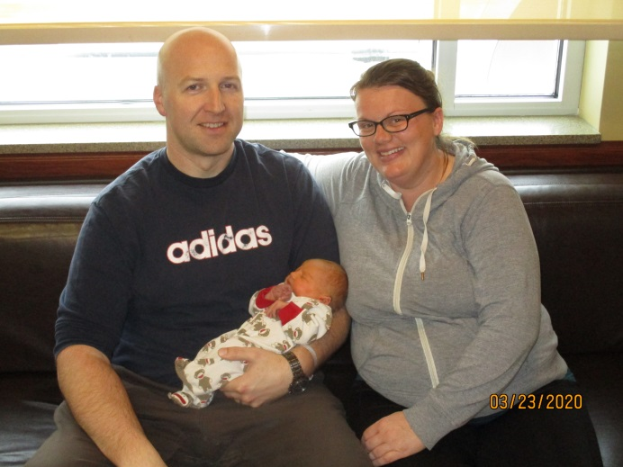

Hope’s parents, Alison and Jody Boeckman, live in Blair and have two other children, Hazel (6) and Hudson (4). When asked about her name and if there was any significance to why they chose Hope, they said the decision occurred after her birth since they did not know the baby’s gender prior to her birth. “We didn’t know the gender and we didn’t have any names picked out. Our other children have names that begin with the letter H, so we were pretty sure that we wanted to keep that trend. After she was born, we had a few H names that we liked, but we settled on Hope. We thought the world could use a little hope with everything that’s going on right now.”
The Boeckmans were not new to the delivery experience at MCH&HS as Hudson was also born here. They chose to deliver at MCH&HS because they love the location and have always received quality care at both the hospital and clinic. “We feel lucky to have MCH&HS in our community and have no reason to go anywhere else, “ said Alison. They also enjoyed the quietness on the floor following delivery while in recovery and the one on one care they received from the nursing staff.
Alison spoke highly of their experience at MCH&HS, saying “Dr. Baumberger and her team are amazing. During my entire pregnancy, we received great care. Dr. Baumberger is very thorough and knowledgeable. Everyone was very supportive and cautious with everything and towards the end of my pregnancy, they made sure that my appointments were during times of the day that were not busy, and they got me back into the exam room quickly without being exposed to too many people in the waiting room. They were so flexible, kind, and committed. Dr. Baumberger even popped into a couple of my appointments while she was supposed to be on vacation. She truly cares about her patients.”
So what is it like to bring a child into the world during such a challenging time? For Alison, it certainly added to the worry new moms and parents experience. “Being pregnant is stressful, in general. There’s always something to worry about, and I will always have the worst case scenario playing out in my head…Is the baby still healthy? Is the baby’s heart still beating? Is the cord around the baby’s neck? Adding COVID-19 to the other stresses of being pregnant was really worrisome, especially considering there’s so little known about the virus. Nobody knows for sure it it can be passed from mother to baby or how it affects the baby if he or she gets it. All of the unknowns about parenthood in general are difficult, but throwing a worldwide pandemic into the mix really changes the ballgame.”
Healthcare facilities all over the country are taking extra precautions to protect patients and visitors from the spread of COVID-19. The MCH&HS Labor and Delivery department is doing its part. They are limiting visitors in order to protect the health and safety of newborns and their moms and have implemented a policy that for now allows one healthy adult visitor per mom and baby and no children, including siblings, are allowed on the unit. Though the extra precautions are necessary during this time, they are not easy for new parents and families.
“I think the hardest part of delivering and recovery was that there were no visitors allowed aside from my husband. Telling grandparents and friends that we couldn’t have visitors was hard, but we all understood why. We were looking through the baby books of our older kiddos before we went to the hospital to deliver, and seeing the pictures of all the visitors we had and seeing the siblings being introduced right away in the hospital brought a little pang of sadness, knowing that Hope wouldn’t have that experience. Now that we’re home, we’ve had to tell a lot of people that they are unable to visit at this time. We’ve made a lot of video calls to introduce Hope to friends and family.”
Angie Livingston, Labor and Delivery Lead at MCH&HS, recognizes how hard it is for new parents and families who are welcoming a baby into their lives, but understands the importance of following the rules to keep them safe. She is proud of her team for working hard and doing their best to keep their new babies and moms protected, while at the same time making their delivery and stay at MCH&HS a wonderful experience. “We feel fortunate to be a part of their experience and are happy the Boeckmans chose to deliver here. Welcoming a child into the world is an amazing experience and we strive to make it special for new moms and families. Their safety is always our priority. ”
The Labor and Delivery team and everyone at MCH&HS is happy the Boeckmans chose MCH&HS and are grateful they played a part in bringing Hope into the world. Little Hope’s arrival has given them all hope of brighter days ahead.

