DODGE | SAUNDERS | WASHINGTON

Memorial Community Hospital
and
Health System

2019 Community Health Needs Assessment

Report prepared by Schmeeckle Research in conjunction with the Three Rivers Public Health Department

October 2019
Executive Summary

A joint Community Health Needs Assessment was conducted by the Three Rivers Public Health Department, in partnership with Memorial Community Hospital and Health System (MCH&HS) for the counties comprising the Three Rivers District- Dodge, Saunders, and Washington. For the purposes of the MCH&HS Community Health Needs Assessment, the primary service area was defined as Washington County, NE, based on patient data that demonstrated 75-90% of patients served in calendar year 2018 resided in Washington County. Primary and secondary data were collected, analyzed and interpreted to derive health priorities for MCH&HS and community partners to collectively address over the next three years, beginning January 1, 2020 and concluding December 31, 2022. From this comprehensive assessment, 3 health priorities were identified for Washington County. MCH&HS will work with internal teams and external partners to further prioritize the community health needs identified in the CHNA, dedicate resources and implement impactful activities with measurable outcomes through the Community Health Improvement Plan (CHIP) to be published in December 2019.

Community Definition
Memorial Community Hospital and Health System is located in Blair, NE and largely serves the Washington and Burt County areas with a hospital and three rural clinics. Washington County was identified as the community for this CHNA, as it is the primary service area for MCH&HS. Some data charts will show other counties in the Three Rivers Public Health Department as data was compiled for all in the district, but for this CHNA, Washington County is the community being served by MCH&HS. See Figure 3 in the report below for a map of MCH&HS’s Primary Service Area but please note that Burt County is directly north of Washington County and in a different health department’s jurisdiction.

Acknowledgements

Every three years, Three River Public Health Department (3RPHD) in collaboration with partners Methodist Fremont Health, Memorial Community Hospital & Health System and Saunders Medical Center completes a Community Health Needs Assessment (CHNA) which then informs to form the Community Health Improvement Plan (CHIP) for Dodge, Washington, and Saunders Counties in eastern Nebraska. This project was made possible through grant funding from the State of Nebraska Department of Health and Service, Division of Public Health, Community Health and Performance Management and Region 6 Behavioral Health Care.

In 2019, 3RPHD added a MAPP (Mobilizing for Action through Planning and Partnerships) Steering Committee to help guide the process which was not utilized in the past. The committee included members from each county served by 3RPHD and each of the collaborating hospitals. We would like to thank all the MAPP Steering Committee members for their hard work and guidance.

MAPP Steering Committee Members
Terra Uhing | Three Rivers Public Health Department
Kevin Eairleywine | Fremont Public Schools
Stacie Sabatka | Saunders Medical Center
Amber Kavan | Saunders Medical Center
Amber Pelan | Saunders County Youth Services
Laura Willey | Memorial Community Hospital & Health System
Jill Gossett | Methodist Fremont Health
Jackie Beaton | Methodist Fremont Health
Shayla Linn | Fremont Family Coalition
Scott Jensen | Methodist Fremont Health
Sofia Toben | Three Rivers Public Health Department
Coartney DiGiorgio | Three Rivers Public Health Department
Lindsey Cork | Three Rivers Public Health Department

Another first for the 2019 CHNA was the addition of a Community Health Survey. A survey with nearly 170 health related questions was administered to individuals who live and work in Dodge, Washington, and Saunders counties to learn what community members saw as the most important health issues to address. The administration of this survey was made possible through grant money from the State of Nebraska Department of Health and Service, Division of Public Health, Community Health and Performance Management to use the online survey software Qualtrics. Memorial Community Hospital & Health System also provided $600 in gift cards as incentive for individuals to complete the survey.

We would like to thank Schmeeckle Research of Lincoln, NE who assembled the CHNA and presented the data at each of the community CHIP meetings and Deb Burnight with Facilitated Resources who facilitated each of the community CHIP meetings.

Contents
Overview of the Community Health Needs Assessment 5
Community Health and the Local Public Health System 6
Description of Data Sources 7
Three Rivers Public Health Department: Demographic and Socioeconomic Characteristics 8
Demographics 9
Veterans 12
Poverty 16
Food and Housing Insecurity 21
Single Parent Families 23
Minority Populations 25
Access to Health Services 27
Mental Health 32
Bullying 35
Youth Substance Abuse 37
Adult Alcohol and Tobacco Use 40
Alcohol Use and Binge Drinking among 19-25-Year-Olds 46
Alcohol-Impaired Driving 47
Motor Vehicle Safety 49
Unintentional Injury 51
Crime 52
Foster Care and Child Abuse/Neglect 55
Education 56
Physical Activity 60
Nutrition 63
Obesity 64
Health Screening 66
General Health Metrics 68
Cancer 70
Heart Disease 76
Stroke 78
High Blood Pressure and Cholesterol 80
Diabetes 81
Respiratory and Pulmonary Illnesses 83
Child and Adolescent Mortality 86
Maternal and Infant Health 87
Teen Pregnancy 90
Sexually Transmitted Disease 91
Alzheimer’s Disease 93
Arthritis 94
Oral Health 95
Kidney Disease 96
Flu and Pneumonia Vaccination 97
Child Immunization 99
Environmental Health 101
Conclusion: Community Health Needs 105
References 111

Overview of the Community Health Needs Assessment

Under the direction of the Three Rivers Public Health Department, the 2019 Community Health Needs Assessment has been created for the three counties in the Three Rivers Health District (Dodge, Saunders, and Washington Counties in Nebraska). This assessment is basis for the Community Health Improvement Plan (CHIP). This assessment also serves as a reference document for the non-profit hospitals in the district to assist in strategic planning. It is the purpose of this assessment to inform all interested parties about the health status of the population within the district and to provide community partners with a wide array of data that can be used to educate and mobilize the community and its resources to improve the health of the population.

The Community Health Needs Assessment process is collaborative and is intended to serve as a single data report for multiple coalitions, organizations, and hospitals in the three-county region unified by the Three Rivers Public Health Department. It is the goal of the Community Health Needs Assessment to describe the health status of the population and identify areas for health improvement, with the hope that the data from this report will be used to target strategic initiatives focused on the areas of highest public health need in the Three Rivers District. This assessment will be updated and revised every three years, thus providing communities with up to date data to evaluate progress made towards identified health priorities, and for the selection of new ones.

This report contains a broad array of demographic and public health data (see a description of the main sources of data in the “Description of Data Sources” section (page 3). Additional reports have been created for each county in which the county-level data indicative of need is highlighted.

Schmeeckle Research of Lincoln, NE assembled this assessment of public health and community well-being under the direction of the Three Rivers District Health Department.

Community Health and the Local Public Health System

Community health includes a broad array of issues addressed by numerous agencies. Topics that fall under community health include such things as access to health care, child welfare, crime, alcohol and tobacco use, drug use, poverty, obesity, diabetes, teen pregnancy, teen sexual activity, healthy children, environmental factors affecting health, cancer, heart disease, and a broad array of other epidemiological topics.

Addressing needs of community health goes far beyond the work of hospitals and the public health department. A broad network of agencies must work in collaboration to meet the diverse health needs of the community. An example of the local public health system network is shown in Figure 1 below, in which over 20 agencies collaborate in various ways in order to form a multi-connected network of public, private, faith based, non-profit, and for-profit agencies that effectively addresses the health needs of the community.

Figure 1: The Local Public Health System (as an example)
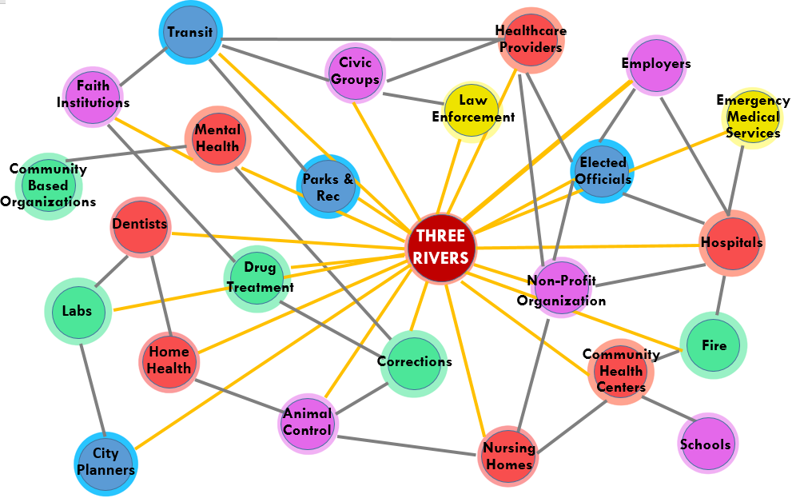
Source: Nebraska Rural Health Association

Description of Data Sources

A broad array of sources provide data for this report. Following is a summary of the most frequently cited sources (Figure 2). Note that statistical significance is only indicated on Behavioral Rick Factor Surveillance System (BRFSS) data. None of the other data sources provided indication of statistical significance.

Figure 2: Frequently Cited Data Sources
Data Source | Description
Behavioral Risk Factor Surveillance System (BRFSS) | - A comprehensive, annual health survey of adults ages 18 and over on risk factors such as alcohol use, tobacco use, obesity, physical activity, health screening, economic stresses, access to health care, mental health, physical health, cancer, diabetes, and many other areas impacting public health. Note that all BRFSS data are age-adjusted, except for indicators keying on specific age groups. The data are also weighted by other demographic variables according to an algorithm defined by the CDC.
County Health Rankings | - A wide array of data from multiple Sources combined to give an overall picture of health in a county. Examples of data include premature deaths, access to locations for physical activity, ratio of population to health care professionals, violent crimes, and many other indicators. County Health Rankings provides health outcomes and health factors rankings for 80 counties in Nebraska.
Nebraska Crime Commission | - Annual counts on arrests (adult and juvenile) by type submitted voluntarily by local and State-level police departments.
Nebraska Department of Education | - Data contained in Nebraska's annual State of the Schools Report, including graduation and dropout rates, student characteristics, and student achievement scores.
Nebraska Department of Health and Human Services (DHHS) | - A wide array of data around births, mortality, child abuse and neglect, health professionals, and other areas. Note that all mortality data are age-adjusted and are based on the place of residence and not the occurrence of death.
Nebraska Risk and Protective Factor Student Survey (NRPFSS) | - A survey of youth in grades 8, 10, and 12 on risk factors such alcohol, tobacco, and drug use, and bullying. Note that NRPFSS data are not considered to be representative of the entire State of Nebraska due to issues with the sampling methodology. Therefore, use caution when comparing Three Rivers to the State.
U.S. Census/American Community Survey | - U.S. Census Bureau estimates on demographic elements such as population, age, race/ethnicity, household income, poverty, health insurance, single parent families, and educational attainment. Annual estimates are available through the American Community Survey.

Three Rivers Public Health Department: Demographic and Socioeconomic Characteristics

Overview
Population (2018 estimate) ª 78,761 (State: 1,929,268)
Population Change (2010-2018) ª 1.4% (State: 5.6%)
Unemployment Rate (April 2019) ^{b} 2.8% (State: 2.9%)
Rural population (2010) ^{c} 45.1% (State: 26.9%)
Total Land Area 1,697 sq. miles (State: 77,354 sq. miles)

ª: Annual Estimates of the Resident Population: April 1, 2010 to July 1, 2018. Table PEPANNRES. Population estimate as of July 1, 2018.
^{b}. Nebraska Department of Labor, Labor Market Information, Local Area Unemployment Statistics (2019)
^{c}. Census population estimates (2010)

Figure 3: Location of Three Rivers District, Counties, Cities, Rural Health Clinics and Hospitals
Sources: TIGER/Line Shapefiles - Census Bureau. Nebraska Department of Health and Human Services (location of hospitals and rural health clinics), 2018.

Demographics

Total population of the Three Rivers District is 78,761 (Figure 4).

Figure 4: Population (2018)
Dodge County | Saunders County | Washington County | Three Rivers
36,791 | 21,303 | 20,667 | 78,761
Source: U.S. Census/American Community Survey 5-Year Estimates (2018)

As a whole, the Three Rivers District is 90.4% White non-Hispanic. There is a significantly sized minority population in Dodge County (Figure 5). See also the “Minority Populations” section below (page 12).

Figure 5: Race/Ethnicity (2017)
 | Dodge County | Saunders County | Washington County | Three Rivers Total | Nebraska
White  (non-Hispanic) | 84.9% | 95.6% | 94.7% | 90.4% | 79.8%
Minority | 15.1% | 4.4% | 5.3% | 9.6% | 20.2%
Source: U.S. Census/American Community Survey 5-Year Estimates (2017). Table DP05

The Three Rivers District has a median age of 40.2, which is 3.9 years older when compared to the median age for the State (Figure 6).

Figure 6: Median age (2017)
Dodge County | Saunders County | Washington County | Three Rivers* | Nebraska
39.1 | 41.0 | 41.2 | 40.2 | 36.3
*An average weighted by the population in each county. Source: U.S. Census/American Community Survey 5-Year Estimates (2017). Table DP05

Among the three counties in the Three Rivers District, Dodge County has the highest percentage (18.6%) of the 65 or older population. As a whole, 17.8% of the Three Rivers District is 65 or older (compared to 14.7% for the State) (Figure 7).

Figure 7: Number and percentage of the 65 and over population (2017)
Dodge County | Saunders County | Washington County | Three Rivers | Nebraska
6,820  (18.6%) | 3,651  (17.4%) | 3,387  (16.6%) | 13,858 (17.8%) | 278,598 (14.7%)
Source: U.S. Census/American Community Survey 5-Year Estimates (2017)

Just under one-fourth (24.1%) of the Three Rivers population is under the age of 18 (Figure 8).

Figure 8: Number and percentage of the under 18 population (2017)
Dodge County | Saunders County | Washington County | Three Rivers | Nebraska
8,642  (23.6%) | 5,241  (25.0%) | 4,918  (24.1%) | 18,801 (24.1%) | 469,819 (24.8%)
Source: U.S. Census/American Community Survey 5-Year Estimates (2017)

From 2013 to 2017, the birth rate was lower for each of the three counties in the Three Rivers District than it was for the State. For 2013-2017 years combined, there were 4,801 births in the district, which makes for a rate of 12.4 births per 1,000 population (compared to a rate of 13.9 per 1,000 population for the State) (Figure 9).

Figure 9. Number of births and birth rate per 1,000 population
 | 2013-2017
Dodge County | 2,480 (13.6)
Saunders County | 1,214 (11.6)
Washington County | 1,107 (10.9)
Three Rivers | 4,801 (12.4)
Nebraska | 131,993 (13.9)
Source: Nebraska DHHS, Vital Records (2019)

Dodge County stands out as having a notably lower median household income and per capita income as compared to the State. Saunders and Washington Counties each have higher median household incomes and per capita incomes as compared to the State (Figure 10).

Figure 10: Income (2017)
 | Dodge County | Saunders County | Washington County | Three Rivers* | Nebraska
Median household income | $51,748 | $65,015 | $66,485 | $59,203 | $56,675
Per capita income | $27,162 | $31,163 | $33,136 | $29,812 | $29,866
*An average weighted by the population in each county. Source: U.S. Census/American Community Survey 5-Year Estimates (2017). Tables S1901 & DP03

According to the 2010 Census data, 45.1% of the population in the Three Rivers District live in rural areas, compared to 26.9% for Nebraska. Two-thirds of the population in Saunders County live in rural communities (66.5%), followed by Washington County (61.2%), and then by Dodge County (25.1). Figure 11.

Figure 11: Number and percentage of rural population (2010)
 | Population | # Rural | % Rural
Dodge County | 36,707 | 9,220 | 25.1%
Saunders County | 21,057 | 13,816 | 66.5%
Washington County | 20,721 | 12,390 | 61.2%
Three Rivers | 78,485 | 35,426 | 45.1%
Nebraska | 1,920,076 | 490,655 | 26.9%
Source: Census Population Estimates (2010).

Veterans

Across the Three Rivers District there are 6,651 veterans, accounting for 9.8% of the total population age 18 and over (Figure 12).

Figure 12: Veterans (2017)
 | Dodge County | Saunders County | Washington County | Three Rivers | Nebraska
Number of veterans | 2,597 | 1,526 | 1,699 | 5,822 | 122,311
Veterans as percentage of total population age 18 years and over | 9.3% | 9.7% | 11.0% | 9.8% | 8.6%
Source: U.S. Census/American Community Survey 5-Year Estimates (2017). Table S2101

Compared to the State, there is a lower proportion of younger veterans in the Three Rivers District. Veterans aged 18 to 34 comprise just 6.1% of the total veteran population of the Three Rivers District (compared to 9.2% for the State) (Figure 13).

Figure 13: Age of veterans (2017)
 | Dodge County | Saunders County | Washington County | Three Rivers* | Nebraska
18 to 34 years | 5.3% | 5.3% | 8.3% | 6.1% | 9.2%
35 to 54 years | 20.3% | 20.6% | 25.0% | 21.6% | 23.9%
55 to 64 years | 15.1% | 15.7% | 16.0% | 15.5% | 17.2%
65 to 75 years | 26.1% | 29.4% | 28.6% | 27.6% | 25.4%
75 years and over | 33.2% | 29.0% | 22.1% | 29.2% | 24.3%
*An average weighted by the population in each county. Source: U.S. Census/American Community Survey 5-Year Estimates (2017). Table 2101

Across the State veterans have considerably lower rates of poverty compared to non-veterans. In the Three Rivers District an estimated 7.4 percent of veterans are in poverty, compared to 9.5 percent for nonveterans (Figure 14).

Figure 14: Poverty rates: veterans and non-veterans (2017)
 | Dodge County | Saunders County | Washington County | Three Rivers* | Nebraska
Veterans in poverty | 8.8% | 4.4% | 8.0% | 7.4% | 5.8%
Non-veterans in poverty | 11.4% | 7.5% | 8.2% | 9.5% | 11.3%
*An average weighted by the population in each county. Source: U.S. Census/American Community Survey 5-Year Estimates (2017). Table S2101

Poverty rates among veterans have steadily increased in the Three Rivers District, from 4.5 percent in 2013 to 7.4 percent in 2017, while poverty rates among veterans in the State have been stable, around 5.8 percent during the same time period (Figure 15).

Source: U.S. Census/American Community Survey 5-Year Estimates (2017). Table S2101

Washington County experienced the highest percentage change increase in poverty rates among veterans between 2013 and 2017 (4.0%), followed by Dodge County (3.2%), and then by Saunders County (1.2%). Figure 16.

Figure 16: Poverty Rate Trends among Veterans by County: 2013-2017
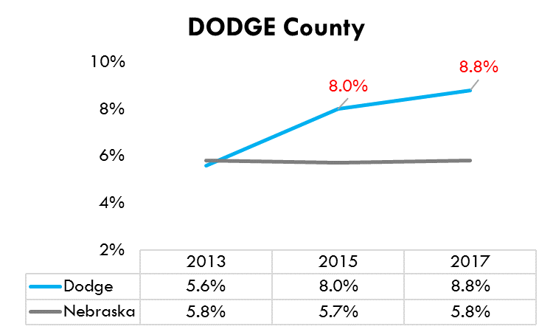 | 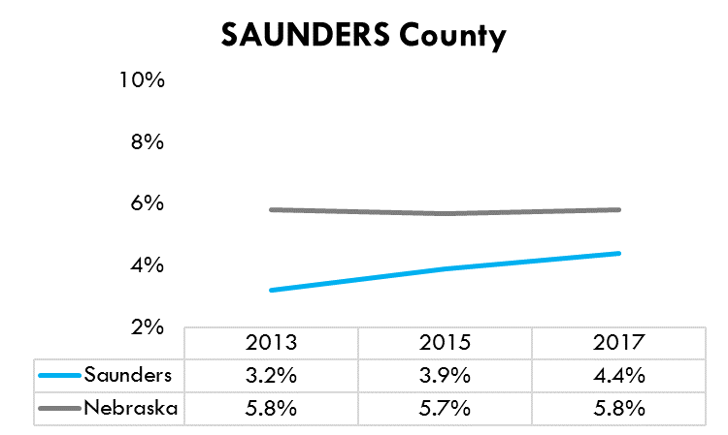 | 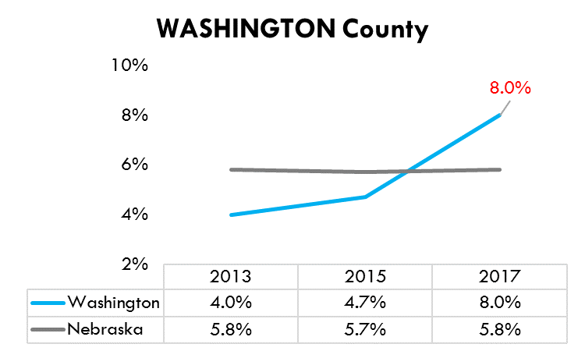
Source: U.S. Census/American Community Survey 5-Year Estimates (2013, 2015 and 2017). Table S2101

Across the State veterans have considerably higher rates of disability compared to non-veterans. In the Three Rivers District an estimated 33.0 percent of veterans have a disability, compared to 14.7 percent for non-veterans. Figure 17.

Figure 17: Disability status (2017)
 | Dodge County | Saunders County | Washington County | Three Rivers* | Nebraska
Veterans with a disability | 33.2% | 37.4% | 28.0% | 33.0% | 29.4%
Non-veterans with a disability | 15.0% | 13.4% | 15.6% | 14.7% | 12.8%
*An average weighted by the population in each county. Source: U.S. Census/American Community Survey 5-Year Estimates (2017). Table S2101

Disability rates among veterans have steadily increased in the Three Rivers District, from 28.9 percent in 2013 to 33.0 percent in 2017, an increase of 4.1 percent. Disability rates among veterans in the State have also increased, from 26.2 percent in 2013 to 29.4 percent in 2017, a 3.2 percent increase (Figure 18).

Source: U.S. Census/American Community Survey 5-Year Estimates (2013, 2015 and 2017). Table S2101

Saunders County experienced the highest percentage change increase in disability rates among veterans between 2013 and 2017 (9.8%), followed by Dodge County (4.1%). Washington County experienced a percentage change decrease in disability rates between 2013 and 2017 (-2.1%). Figure 19.

Figure 19: Disability Rates trends among Veterans by County: 2013-2017
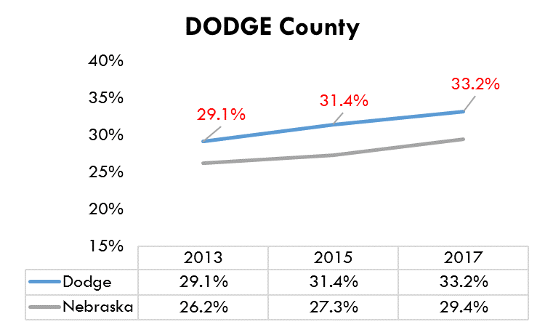 | 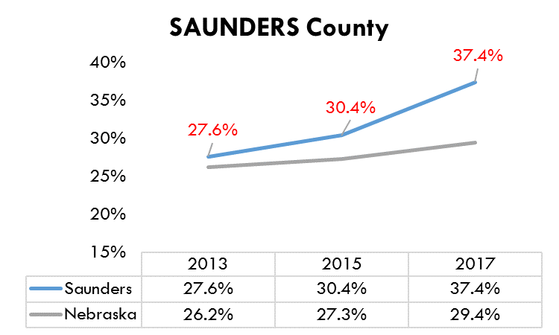 | 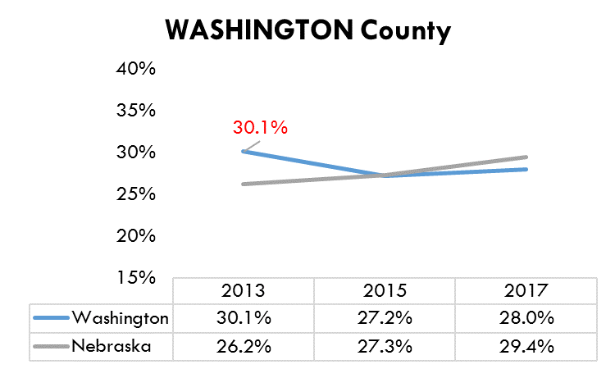
Source: U.S. Census/American Community Survey 5-Year Estimates (2013, 2015 and 2017). Table S2101

Poverty

According to the U.S. Census, 11.1 percent of the total Three Rivers population is in poverty (compared to 12.0% for the State). Between 2013 and 2017, the poverty rate in Three Rivers District increased by 1.9 percent, while the poverty rate in Nebraska decreased 0.8 percent.

Saunders and Washington Counties have r poverty rates that are lower than the State, while Dodge County has higher rates of poverty as compared to the State. Dodge County experienced the highest percent change in poverty between 2013 and 2017 (+2.5%), followed by Washington County (+2.1%), and then by Saunders County (+1.0%). Figure 20.

Source: U.S. Census/American Community Survey 5-Year Estimates (2013 and 2017). Table S1701

An estimated total of 8,496 individuals were in poverty in the Three Rivers District in 2017, 1,530 more when compared to 2013. While the total number of individuals in poverty in Nebraska decreased 3.7 percent between 2013-2017, Three Rivers District experienced a 22 percent increase during the same time period (Figure 21).

Figure 21: Number of individuals in poverty and percent change (2013 and 2017)
 | 2013 | 2017 | % Change 2013-2017
Dodge County | 3,801 | 4,677 | 23.0%
Saunders County | 1,648 | 1,860 | 12.9%
Washington County | 1,517 | 1,959 | 29.1%
Three Rivers | 6,966 | 8,496 | 22.0%
Nebraska | 228,789 | 220,330 | -3.7%
Source: U.S. Census/American Community Survey 5-Year Estimates (2013 and 2017). Table S1701.

The under 18 years of age population in poverty has also increased in the Three Rivers District, from 12.3 percent in 2013 to 16.9 percent in 2017, 1.3 percent higher when compared to the State (16.9% vs. 15.6%, respectively). In 2013, the Three Rivers District poverty rate for the under 18 years of age population was 5.1 percent lower when compared to the State (12.3% vs. 17.4%, respectively).

2017 Saunders and Washington County poverty rates among the under 18 years of age population are lower than the State, while Dodge County has higher poverty rates as compared to the State. Dodge County experienced the highest percent change in poverty among individuals under 18 years of age between 2013 and 2017 (+5.7%), followed by Washington County (+3.0%), and then by Saunders County (+2.5%), while the State experienced a decrease in poverty rates of 1.8 percent among the under 18 years of age population during the same time period. Figure 22.

Source: U.S. Census/American Community Survey 5-Year Estimates (2013 and 2017). Table S1701

An estimated total of 3,146 individuals under 18 years of age were in poverty in the Three Rivers District in 2017, 756 more when compared to the year 2013. The number of individuals in poverty under 18 years of age in the Three Rivers District increased 31.6 percent between 2013 and 2017, while at the State level decreased 8.4 percent. Dodge County experienced the greatest increase (+41.4%), followed by Washington County (+25.5%), then by Saunders County (+18.9%). Figure 23.

Figure 23: Number of individuals under 18 years of age in poverty and percent change (2013 and 2017)
 | 2013 | 2017 | % Change 2013-2017
Dodge County | 1,183 | 1,673 | 41.4%
Saunders County | 634 | 754 | 18.9%
Washington County | 573 | 719 | 25.5%
Three Rivers | 2,390 | 3,146 | 31.6%
Nebraska | 78,578 | 71,957 | -8.4%
Source: U.S. Census/American Community Survey 5-Year Estimates (2013 and 2017). Table S1701

Unemployment

According to the Nebraska Department of Labor, the unemployment rate (as of April 2019) is 0.1 percent lower in the Three Rivers District when compared to the State of Nebraska (2.8% vs. 2.9%). The three counties in the Three Rivers District show a similar unemployment rate (2.8% each). Figure 24.

Figure 24: County, Three Rivers, and State Unemployment Rates (April 2019)
County | Unemployed | Labor Force | % Unemployed
Dodge | 541 | 19,549 | 2.8%
Saunders | 309 | 11,137 | 2.8%
Washington | 314 | 11,411 | 2.8%
Three Rivers | 1,164 | 42,097 | 2.8%
Nebraska | 30,373 | 1,035,241 | 2.9%
Source: Nebraska Department of Labor, Labor Market Information, Local Area Unemployment Statistics

Unemployment rates have been steadily decreasing in the Three Rivers District after the Great Recession of 2008-2009. Saunders County experienced the greatest decrease in unemployment rates among all counties in the District since 2009 (-2.7%), followed by Dodge County (-2.5%) and then by Washington County (-2.1%). Figure 25.

Figure 25: Three Rivers unemployment rates 2009 - 2018
County: | 2009 | 2010 | 2011 | 2012 | 2013 | 2014 | 2015 | 2016 | 2017 | 2018 | %Change 2009-2018
Dodge | 5 | 5.3 | 4.9 | 4.5 | 4.2 | 3.6 | 3.3 | 3.1 | 2.8 | 2.5 | -2.5
Saunders | 5 | 4.8 | 4.6 | 4.2 | 4 | 3.5 | 3.1 | 3.1 | 2.8 | 2.3 | -2.7
Washington | 4.6 | 4.6 | 4.4 | 3.8 | 3.7 | 3.2 | 3 | 3.2 | 3.1 | 2.5 | -2.1
Sources: Unemployment rates 2009-2017: 1) Bureau of Labor Statistics, Local Area Unemployment Statistics (LAUS) data. 2) Nebraska Department of Labor, Labor Market Information, Local Area Unemployment Statistics

In 2018-2019, 5,511 children in the Three Rivers District were eligible for free and reduced school meals, and over half (51.4%) of the children in Dodge County were eligible. Saunders County experienced a decrease in the percentage of children eligible for free and reduced meals, from 34.2 percent in 2012-2013 to 31.2 percent in 2018-2019. While the State experienced a decrease in the percentage of children eligible for free and reduced meals between 2012-2013 and 2018-2019 (-3.3%), the Three Rivers District experienced a slight increase of 0.2 percent during the same time period (Figure 26).

Figure 26. Number and percentage of children eligible for free and reduced school meals
 | 2008-2009 | 2012-2013* | 2018-2019
Dodge County | 2,073 (39%) | 3,036 (51.7%) | 3,463 (51.4%)
Saunders County | 815 (26%) | 1,064 (34.2%) | 1,173 (31.2%)
Washington County | 709 (16%) | 763 (20.7%) | 875 (23.1%)
Three Rivers | 3,597 (28%) | 4,863 (38.4%) | 5,511 (38.6%)
Nebraska | 93,575 (36%) | 133,972 (44.2%) | 148,813 (40.9%)
*Increase in the percentage of children eligible for free and reduced school meals may be due to a change in the guidelines for determining eligibility.
Source: Nebraska Dept. of Education (https://www.education.ne.gov/dataservices/data-reports/)

In 2016, 5,639 Three Rivers District children were enrolled in Medicaid or the Children’s Health Insurance Plan (CHIP). Of those, 3,625 (64.3%) were from Dodge County (Figure 27).

Figure 27. Number and percentage of children enrolled in Medicaid or CHIP
 | 2009 | 2013 | 2016
Dodge County | 3,051 (36.0%) | 3,505 (40.2%) | 3,625 (37.7%)
Saunders County | 941 (18.4%) | 1,174 (22.1%) | 1,145 (20.0%)
Washington County | 774 (15.4%) | 803 (16.2%) | 869 (15.7%)
Three Rivers | 4,766 (25.6%) | 5,482 (28.9%) | 5,639 (27.0%)
Nebraska | 140,281 (31.5%) | 161,729 (35.5%) | 161,530 (31.0%)
Source: Nebraska DHHS, Financial & Program Services, contained in Kids Count (2016). https://datacenter.kidscount.org/data/tables/2049-medicaid-and-schip-eligible-children?loc=29&loct=5#detailed/5/4346,4397,4408/true/870/any/4302

Food and Housing Insecurity

Food and housing insecurity can affect the physical and mental health of affected individuals and impede their ability to achieve optimal health. The United States Department of Agriculture (USDA) Economic Research Service defines food insecurity as reduced food intake or reduced dietary quality because the household lacked money and other resources for food. The U.S. Department of Health and Human Services defined housing insecurity as high housing costs in proportion to income, poor housing quality, unstable neighborhoods, overcrowding, or homelessness (NE DHHS, 2016).
“Research from the Tufts Friedman School suggests that poor eating causes nearly 1,000 deaths each day in the United States from heart disease, stroke or diabetes.”

According to the USDA Economic Research Service, about 1 in 7 households in Nebraska (14.8%) were food insecure between 2013 and 2015, an increase from 10.4 percent in Nebraska between 2001 and 2003. Current food insecurity rates in Nebraska are higher when compared to the national average for the 2013-2015 period (13.7%).

The Nebraska Behavioral Risk Factor Surveillance System (BRFSS) measures food and housing insecurity based on moderate to high stress related to not having enough money to buy nutritional foods and not having enough money to pay the rent or mortgage among those who rent or own their home. In 2015, 25.9 percent of Three Rivers adults reported housing insecurity, and 17.5 percent reported food insecurity (Figures 28 and 29). See the notes below each figure for definitions of housing and food insecurity.

*Percentage who report they were always, usually, or sometimes worried or stressed about having enough money to pay their rent or mortgage. Source: Behavioral Risk Factors Surveillance System (2017)

*Percentage who report that they were always, usually, or sometimes worried or stressed about having enough money to buy nutritious meals. Source: Behavioral Risk Factors Surveillance System (2019)

Single Parent Families

In 2017, more than one-in-four (26.6%) children in the Three Rivers District live in a single parent household, which was lower than the rate of 28.2% for the State as a whole. The percentage of children living in a single parent household in the Three Rivers District increased 4.1 percent between 2013 and 2017, while it increased 0.2 percent at the State level during the same time period. Saunders County experienced the highest increase of children living in in a single parent household, from 15.9 percent in 2013 to 22.6 percent in 2017 (+6.7%), followed by Dodge County (+5.7%), while Washington County experienced a decrease in the percentage of children living in a single parent household, from 20.9 percent in 2013 to 19.1 percent in 2017 (-1.8%). (Figure 30).

*Children living in either female householder, no husband present, families or male householder, no wife present, families, as a percentage of all children living in family households. Source: U.S. Census/American Community Survey 5-Year Estimates (2013 and 2017). Table B09008

Poverty rates for all families in the Three Rivers District increased from 9.3 percent in 2013 to 12.8 percent to 2017 (+3.5%), while it decreased 1.4 percent at the State level during the same time period.

5.2 percent of married couple families with children were in poverty in the Three Rivers District in 2013 and 2017. However, poverty rates among single mother households (“female householder, no husband present”) with children increased 12 percent between 2013 and 2017 (27.2% vs. 39.2%, respectively). Poverty rates among single mother households with children is 7.5 times higher when compared to married couples with children in the Three Rivers District (39.2% vs. 5.2%, respectively). Noticeable is the change of poverty rates among single mothers with children in Washington County which increased from 26.9 percent in 2013 to 50.8 percent in 2017. (Figure 31).

Figure 31: Poverty among families with children under 18 (2013 and 2017)
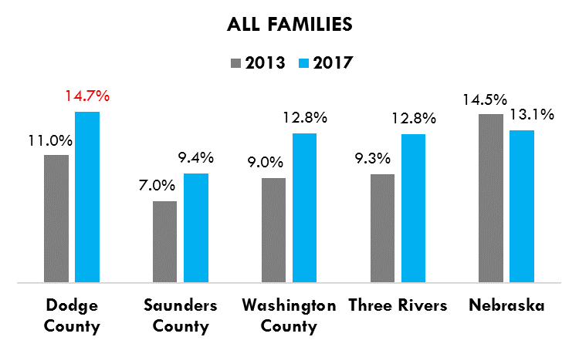 | 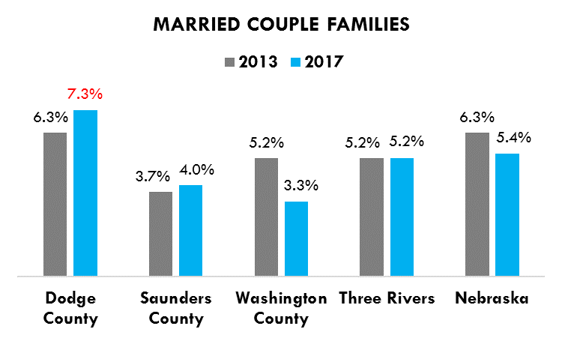
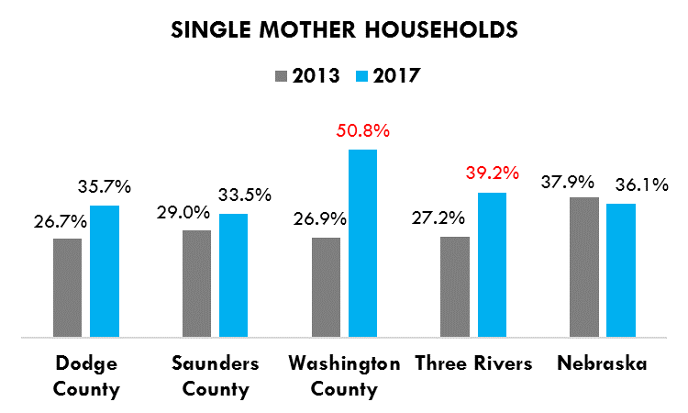
Source: U.S. Census/American Community Survey 5-Year Estimates (2013 and 2017). Table S1702

Approximately one-third of all children in the Three Rivers District and Nebraska are born to unmarried mothers. In Dodge County, 43.5 percent of all births were to unmarried mothers from 2012-2016, accounting for 1,095 births over this five-year period (Figure 32). Note that children born to unmarried mothers and living in a single mother household (also known as “female householder, no husband present family”) are much more likely to be in poverty than children living in married couple families (see Figure 31 above).

Figure 32. Number and percentage of births to unmarried mothers
 | 2006-2010 | 2007-2011 | 2008-2012 | 2009-2013 | 2012-2016
Dodge County | 968 (38.9%) | 964 (40.0%) | 990 (40.6%) | 976 (40.8%) | 1,095 (43.5%)
Saunders County | 274 (21.1%) | 286 (21.7%) | 288 (22.4%) | 274 (21.6%) | 245 (20.5%)
Washington County | 260 (24.1%) | 263 (24.8%) | 255 (25.0%) | 269 (25.8%) | 288 (26.9%)
Three Rivers | 1,502 (30.9%) | 1,513 (31.4%) | 1,533 (32.3%) | 1,519 (32.2%) | 1,628 (34.0%)
Nebraska | 44,729 (33.5%) | 44,658 (33.7%) | 44,305 (33.7%) | 43,854 (33.6%) | 43,530 (33.0%)
Source: Nebraska DHHS, Vital Records (2013 and 2018)

Minority Populations

An estimated total of 7,519 minorities live in the Three Rivers District, the majority of which are of Hispanic/Latino ethnicity (Figure 33). Minorities experienced an increase of 17 percent in the District between 2013 and 2017. During 2013 to 2017, minorities increased by 23.6 percent in Washington County, followed by Dodge County (16.8%), and then by Saunders County (11.7%). Among specific races/ethnicities in the District, Black/African Americans increased by 78.8 percent between 2013 and 2017, followed by American Indian/Alaska Native (19.9%), Asian (14.7%), and then by Hispanic/Latino (14.3%). Native Hawaiian/Pacific Islander representation decreased by 57.2 percent in the District.

Figure 33: Minorities (2017)
 | Hispanic/ Latino | Black/  African-American  NH | Asian  NH | American Indian/ Alaskan Native  NH | Native Hawaiian/ Pacific Islander  NH | Two or More Races  NH | Other  NH | Total Minorities
Dodge County | 4,300 | 265 | 225 | 112 | 62 | 466 | 95 | 5,525
Saunders County | 442 | 63 | 65 | 41 | 0 | 308 | 0 | 919
Washington County | 576 | 194 | 61 | 16 | 0 | 223 | 5 | 1,075
Three Rivers | 5,318 | 522 | 351 | 169 | 62 | 997 | 100 | 7,519
Note: NH=non-Hispanic. Source: U.S. Census/American Community Survey 5-Year Estimates (2017). Table DP05

Among the foreign-born population in the Three Rivers District, 82.6 percent are not U.S. citizens according to the U.S. Census. This is higher than the rate of 63.5 percent for the State (Figure 34).

Figure 34: Foreign-born population (2017)
 | Total foreign-born population | Naturalized U.S. citizen | Not a U.S. citizen
Dodge County | 2,401 | 346 (14.4%) | 2,055 (85.6%)
Saunders County | 238 | 116 (48.7%) | 122 (51.3%)
Washington County | 273 | 45 (16.5%) | 228 (83.5%)
Three Rivers | 2,912 | 507 (17.4%) | 2,405 (82.6%)
Nebraska | 130,660 | 47,740 (36.5%) | 82,920 (63.5%)
Source: U.S. Census/American Community Survey 5-Year Estimates (2017). Table B05001

One-in-ten (11.1%) individuals age five and over in Dodge County speak a language other than English at home, which is comparable to the rate of 11.2 percent for the State. Saunders and Washington Counties have relatively small non-English speaking populations (Figure 35).

Source: U.S. Census/American Community Survey 5-Year Estimates (2017)

Access to Health Services

In 2017, 4.2 percent of the under 18 population in the Three Rivers District is without health insurance coverage (Figure 36), 0.7 percent lower when compared to the year 2013 (4.9%).

Figure 36: Percentage of the population under 18 without health insurance coverage (2017)
Dodge County | Saunders County | Washington County | Three Rivers | Nebraska
5.8% | 2.3% | 3.2% | 4.2% | 5.3%
Source: U.S. Census/American Community Survey 5-Year Estimates (2017). Table S2701

Among the total population under the age of 65 in the Three Rivers District, there were an estimated 6,097 individuals without health insurance in 2017, accounting for 9.5% of the total population under the age of 65 (Figure 37).

Figure 37. Number and percentage of the population under age 65 without health insurance
 | 2010 | 2011 | 2012 | 2015 | 2016 | 2017
Dodge County | 4,006 (13.7%) | 4,252 (14.5%) | 4,020 (13.8%) | 4,251 (14.3%) | 4,208 (14.1%) | 3,954 (13.3%)
Saunders County | 1,788 (10.3%) | 1,800 (10.4%) | 1,742 (10.2%) | 1,376 (8.0%) | 1,057 (6.1%) | 1,009 (5.9%)
Washington County | 1,545 (9.1%) | 1,512 (8.9%) | 1,396 (8.3%) | 1,455 (8.5%) | 1,132 (6.6%) | 1,134 (6.7%)
Three Rivers | 7,339 (11.5%) | 7,564 (11.9%) | 7,158 (11.4%) | 7,082 (11.0%) | 6,397 (10.0%) | 6,097 (9.5%)
Nebraska | 206,100 (13.4%) | 205,574 (13.3%) | 200,265 (12.9%) | 188,004 (11.8%) | 178,149 (11.2%) | 142,548 (10.4%)
Sources: 1) Small Area Health Insurance Estimates, contained in County Health Rankings (2015):2010-2012. 2) U.S. and Census/American Community Survey 5-Year Estimates (2015, 2016, 2017). Table S2701

Among adults age 18-64 in the Three Rivers District, 14.8% reported not having health care coverage in 2017. This represented a notable increase when compared to 10.5 percent in 2015 (Figure 38).

Source: Behavioral Risk Factors Surveillance System (2017)

In 2017, 20.1 percent of the Three Rivers population reported not having a personal doctor or health care provider, which represented an increase from 15.9 percent in 2016, and for first time since 2011, the Three Rivers District overpassed the percentage of the population who do not have a personal health care provider when compared to the State (20.1% vs. 19.9%, respectively). (Figure 39).

Source: Behavioral Risk Factors Surveillance System (2017)

In 2017, 68.2 percent of Three Rivers adults reported having a routine checkup in the past year (compared to 66.7% for the State) (Figure 40).

*Statistically significant difference between Three Rivers and the State. Source: Behavioral Risk Factors Surveillance System (2017)

In 2017 among adults in the Three Rivers District, 11.7 percent reported needing to see a doctor but could not due to cost in the past year. A similar percentage was reported for the State (11.7%). (Figure 41).

Source: Behavioral Risk Factors Surveillance System (2017)

Compared to the State, all three counties in the Three Rivers District have a higher ratio of population to primary care physicians, dentists, and mental health providers (Figure 42). The Ratio of population to primary care physicians and dentists slightly decreased between the two dates comparison in the Three Rivers District, while the ratio of population to mental health providers increased in the District.

Figure 42. Ratio of population to health care professionals: Two dates comparison.
 | Ratio of population to PRIMARY CARE PHYSICIANS |  | Ratio of population to DENTISTS |  | Ratio of population to MENTAL HEALTH PROVIDERS
 | 2012 | 2016 | 2013 | 2017 | 2014 | 2018
Dodge County | 1,656:1 | 1,838:1 | 1,739:1 | 1,529:1 | 664:1 | 765:1
Saunders County | 3,471:1 | 2,338:1 | 3,488:1 | 3,008:1 | 3,488:1 | 3,510:1
Washington County | 3,375:1 | 1,873:1 | 3,371:1 | 3,454:1 | 5,056:1 | 2,960:1
Three Rivers | 2,280:1 | 1,947:1 | 2,352:1 | 2,113:1 | 1,194:1 | 1,291:1
Nebraska | 1,405:1 | 1,323:1 | 1,450:1 | 1,321:1 | 435:1 | 401:1
Source: Area Health Resource File/American Medical Association; CMS, National Provider Identification file, contained in County Health Rankings (2019)

Figure 43 displays the number of primary care physicians, dentists, and mental health providers for each of the three counties in the Three Rivers District and Figure 44 displays a larger range of medical professionals.

Figure 43: Number of health care professionals
 | Number of PRIMARY CARE PHYSICIANS |  | Number of DENTISTS |  | Number of MENTAL HEALTH PROVIDERS
 | 2012 | 2016 | 2013 | 2017 | 2014 | 2018
Dodge County | 22 | 20 | 21 | 24 | 55 | 48
Saunders County | 6 | 9 | 6 | 7 | 6 | 6
Washington County | 6 | 11 | 6 | 6 | 4 | 7
Three Rivers | 34 | 40 | 33 | 37 | 65 | 61
Source: Area Health Resource File/American Medical Association; CMS, National Provider Identification file, contained in County Health Rankings (2019)

Figure 44: Number of health professionals in area (2019)
 | Dodge County | Saunders County | Washington County | Three Rivers
Physicians | 61 | 5 | 11 | 77
Family Medicine/General Practice | 12 | 4 | 6 | 22
Gynecology | 0 | 0 | 0 | 0
Internal Medicine | 4 | 0 | 0 | 4
Pediatrics | 4 | 0 | 1 | 5
Obstetrics & Gynecology | 5 | 0 | 0 | 5
Psychiatry | 2 | 0 | 0 | 2
Dentist | 21 | 5 | 4 | 30
Pharmacist | 43 | 10 | 8 | 61
Physical Therapist | 31 | 18 | 19 | 68
Physician Assistant | 11 | 2 | 9 | 22
Family Medicine | 7 | 2 | 6 | 15
Nurse Practitioners (2018) | 22 | 5 | 2 | 29
RN's (2018) | 365 | 80 | 89 | 534
LPN's (2017) | 112 | 45 | 27 | 184
Sources: Nebraska Center for Nursing, Biennial Report 2017-2018. Health Professions Tracking Service (HPTS), University of Nebraska Medical Center, College of Public Health (2019)

Mental Health

In 2017, 8.8 percent of adults in the Three Rivers District reported that their mental health was not good on 14 or more of the past 30 days (i.e., frequent mental distress) (Figure 45).

Source: Behavioral Risk Factors Surveillance System (2017)

In 2017, 18.1 percent of adults in the Three Rivers District reported that they have ever been told by a mental health or medical professional that they have depression (Figure 46).

Source: Behavioral Risk Factors Surveillance System (2017)

In 2012, 10.9 percent of adults in the Three Rivers District reported that they are currently taking medication or receiving treatment for a mental health condition, and 3.9 percent responded to a series of questions that indicated symptoms of a serious mental health illness in the past 30 days (Figure 47).

Figure 47. Mental health indicators among adults 18 and over (2012) *
 | Three Rivers | Nebraska
Currently taking medication or receiving treatment for a mental health condition | 10.9% | 11.0%
Symptoms of serious mental health illness in past 30 days** | 3.9% | 3.2%
*No additional data has been updated since 2012. **Percentage reporting answers to six questions measuring risk for serious psychological distress during the past 30 days based on the Kessler 6 (KS) instrument that generate a score of 13 or higher, suggesting serious mental illness. Source: Behavioral Risk Factors Surveillance System (2012)

Three Rivers District has steadily increased the death rate due to suicide since 2007-2011 combined years, in a similar trend as compared to the State. Within the counties of the District, Dodge County has noticeable increased the death rate due to suicide, from 10.5 percent in 2009-2013 combined years to 15.3 percent in 2013-2017 combined years, the highest death rate among the counties in the District, whereas Saunders County experienced a noticeable decrease death rate due to suicide during the same time period, from 18.9 percent to 13.5 percent. There were 31 suicides in Dodge County during 2013-2017 combined years, compared to 17 in Saunders County, 9 in Washington County, and 57 in the Three Rivers District as a whole. (Figures 48 and 49).

Note: All mortality data from Vital Statistics are based on the place of residence and not the occurrence of death.

Source: Nebraska DHHS, Vital Records (2017)

Figure 49: Number of deaths due to suicide (2013-2017)
Dodge County | Saunders County | Washington County | Three Rivers | Nebraska
31 | 17 | 9 | 57 | 1,210
Source: Nebraska DHHS, Vital Records (2017)

Bullying

Figure 50 presents four indicators of bullying among 8th, 10th, and 12th graders. In 2018, 66.9 percent of 8th graders, 50.5 percent of 10th graders, and 46.9 percent of 12th graders in the Three Rivers District reported some form of being bullied in the past year (either physically, verbally, socially or electronically).

Any type of bullying among Three Rivers Students in 10th and 12th grades substantially decreased between 2016 and 2018. However, all types of bullying for students in 8th grade slightly increased between 2016 and 2018.

For Figure 50 below, the symbol ∆ compares percent of change between 2016 and 2018. The symbol represents that the percentage change in the Three Rivers District was statistically significant between years 2016 and 2018. The symbol – indicates that the change was not statistically significant between those same years. The only types of bullying that did not significantly decrease among 12th graders in the Three Rivers District between 2016 and 2018 were “Physically” and “Electronically”.

Figure 50: Bullying among 8th, 10th, and 12th graders in the past year (2016 and 2018)
 |  | 8th |  |  | 10th |  |  | 12th
 |  | 2016 | 2018 | ∆ | 2016 | 2018 | ∆ | 2016 | 2018 | ∆
Any bullying | Three Rivers | 64.4% | 66.9% | - | 64.3% | 50.5% |  | 57.6% | 46.9%
 | Nebraska | 65.1% | 62.8% |  | 59.6% | 54.6% |  | 51.0% | 48.1%
Physically | Three Rivers | 27.4% | 30.1% | - | 24.4% | 15.9% |  | 12.9% | 10.3% | -
 | Nebraska | 27.8% | 26.8% |  | 19.9% | 17.2% |  | 12.2% | 11.8%
Verbally | Three Rivers | 54.5% | 56.3% | - | 55.2% | 44.9% |  | 48.9% | 38.1%
 | Nebraska | 55.7% | 52.9% |  | 50.9% | 45.8% |  | 42.3% | 39.6%
Socially | Three Rivers | 45.4% | 49.7% | - | 47.6% | 40.5% |  | 45.6% | 38.4%
 | Nebraska | 47.0% | 45.3% |  | 45.2% | 43.0% |  | 40.1% | 39.5%
Electronically | Three Rivers | 22.1% | 25.6% | - | 27.8% | 22.3% |  | 25.4% | 21.3% | -
 | Nebraska | 22.2% | 20.0% |  | 23.4% | 21.3% |  | 20.1% | 19.3%
Source: Nebraska Risk and Protective Factors Student Survey (2016 and 2018)

Figure 51 graphically depicts changes in all types of bullying by grade and year, as well as between Three Rivers District and the State.

Figure 51: Percentage of bullying in 8th, 10th and 12th grades by year: Three Rivers District vs. Nebraska
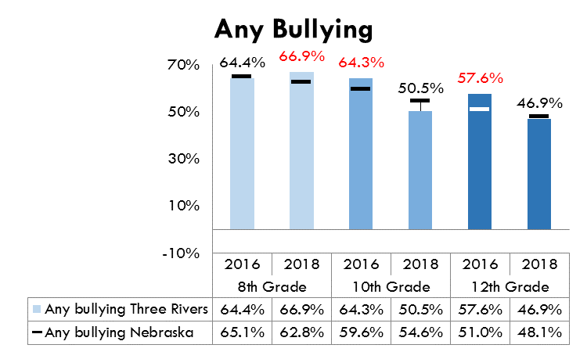
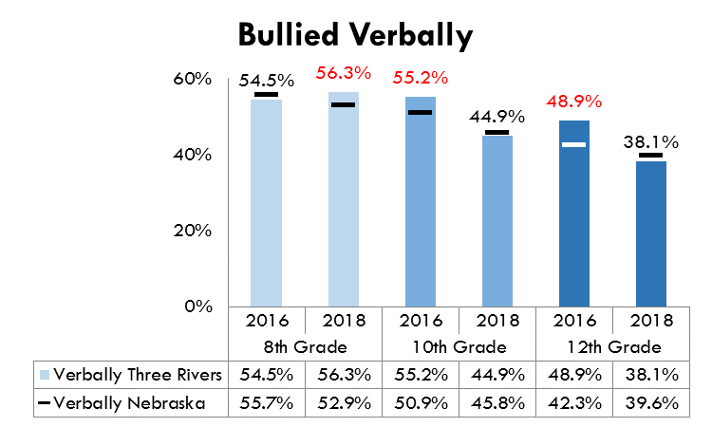 | 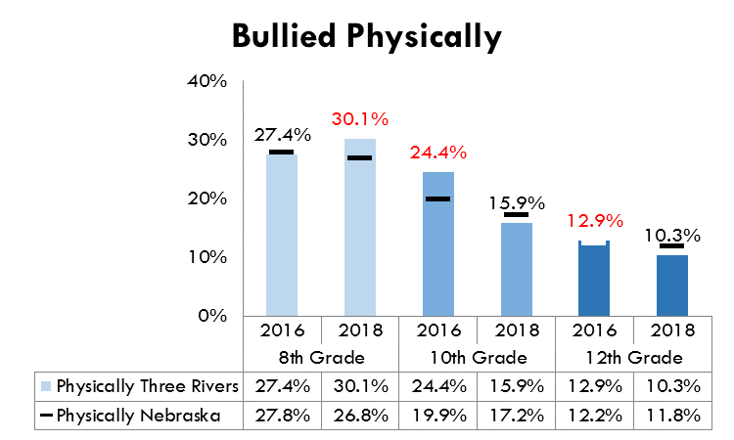
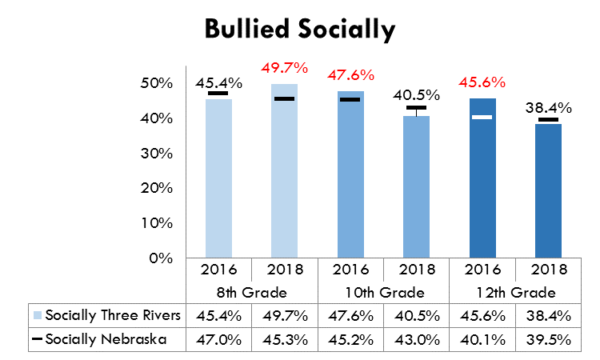 | 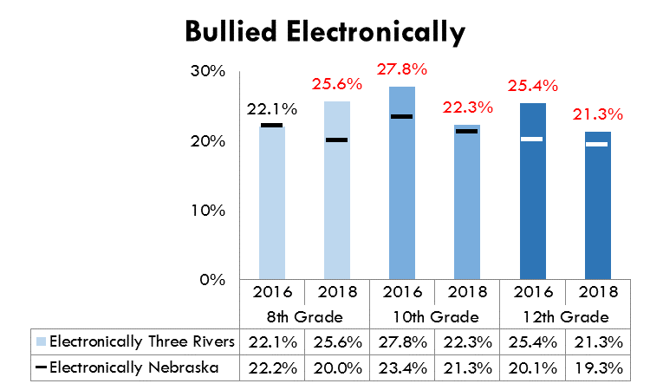
Source: Nebraska Risk and Protective Factors Student Survey (2016 and 2018)

Youth Substance Abuse

Past 30-day alcohol use among youth has generally been on the decline in both the Three Rivers District and the State as a whole from 2003 to 2014, although an increase in alcohol use among all grades was observed at the District and State levels in 2016 and 2018 (Figure 52).

Source: Nebraska Risk and Protective Factors Student Survey (2018)

Past 30-day cigarette use among youth has steady decreased in the Three Rivers District from 2003 to 2018. (Figure 53).

Source: Nebraska Risk and Protective Factors Student Survey (2018).

In 2018, 25.6 percent of 10th graders and 40.5 percent of 12th graders in the Three Rivers District reported electronic vapor use in the past 30 days. In 2018, 10th and 12th graders in the Health District nearly doubled their electronic vapor use when compared to 2016. (Figure 54).

Source: Nebraska Risk and Protective Factors Student Survey (2018)

In 2018, 10.0 percent of 10th graders and 19.3 percent of 12th graders in the Three Rivers District reported marijuana use in the past 30 days. In past years, Three Rivers 12th graders have consistently reported higher rates of past 30-day marijuana use compared to the State. (Figure 55).

Source: Nebraska Risk and Protective Factors Student Survey (2018)

Past 30-day prescription drug use has been decreasing in both the Three Rivers District and the State as whole since 2005. From 2005 to 2018, past 30-day prescription drug use has been consistently higher among Three Rivers youth than in the State. Except, prescription drug use among 10th graders in the District was lower than the State in 2016 (Figure 56).

Source: Nebraska Risk and Protective Factors Student Survey (2018)

Adult Alcohol and Tobacco Use

For 2007-2011 and 2009-2013, tobacco-related death rates in the Three Rivers District are similar with the rest of the State. However, Dodge County has a higher rate of tobacco-related deaths compared to the State. There were 570 such deaths in the Three Rivers District from 2009-2013. Tobacco related deaths by individual years (2015, 2016, 2017), also shows Dodge County with the highest prevalence death rate among all counties in the Three Rivers District. Total number of deaths in the Three Rivers District related to tobacco smoking between 2015 and 2017 was 403 (Figures 57 through 60). Note: All mortality data from Vital Statistics are based on the place of residence and not the occurrence of death.

Source: Nebraska DHHS, Vital Records (2013)

Source: CDC, Smoking-Attributable Mortality, Morbidity, and Economic Costs (SAMMEC). Data provided by Nebraska DHHS (2019)

Figure 59: Number of tobacco-related deaths (2009-2013)
Dodge County | Saunders County | Washington County | Three Rivers | Nebraska
316 | 129 | 125 | 570 | 11,183
Source: Nebraska DHHS, Vital Records (2013)

Figure 60: Aggregated number of tobacco-related deaths (2015, 2016 and 2017)
Dodge County | Saunders County | Washington County | Three Rivers | Nebraska
220 | 102 | 81 | 403 | 7,556
Source: CDC, Smoking-Attributable Mortality, Morbidity, and Economic Costs (SAMMEC). Data provided by Nebraska DHHS (2019)

Cigarette smoking appear to be on the decline since 2011 in the Three Rivers District. In 2017, 15.6 percent of adults reported currently smoking cigarettes. (Figures 61). Smokeless tobacco use has been increasing in the Three Rivers District, from a low of 3.9 percent in 2015 to 7.3 percent in 2017. (Figure 62).

In addition, in the Three Rivers District in 2017, 65.9 percent of current smokers reported that they attempted to quit smoking in the past year (State comparison: 55.6%) (Source: Behavioral Risk Factors Surveillance System, 2017).

Source: Behavioral Risk Factors Surveillance System (2017)

Source: Behavioral Risk Factors Surveillance System (2017)

Rates of alcohol-related deaths are similar with the rest of the State. There were 145 such deaths in the Three Rivers District from 2009-2013 (Figures 63 and 64).

*Data by county was not available for the 2013-2017 combined years. Source: Nebraska DHHS, Vital Records (2013)

Figure 64. Number of alcohol-related deaths (2009-2013) *
Dodge County | Saunders County | Washington County | Three Rivers | Nebraska
77 | 38 | 30 | 145 | 3,042
*Data by county was not available for the 2013-2017 combined years. Source: Nebraska DHHS, Vital Records (2013)

Alcohol-related deaths by individual years (2015, 2016, 2017) showed a decrease in the Three Rivers District, from 36.0 deaths per 100,000 population in 2015 to 30.0 deaths per 100,000 population in 2017. Total number of deaths in the Three Rivers District related to alcohol consumption between 2015 and 2017 was 99 (Figures 65 and 66).

Source: Nebraska DHHS, Vital Records (2017)

Figure 66: Aggregated number of alcohol-related deaths (2015, 2016 and 2017)
Dodge County | Saunders County | Washington County | Three Rivers | Nebraska
51 | 26 | 22 | 99 | 2,194
Source: Nebraska DHHS, Vital Records (2017)

In 2017, 22.0 percent of adults in the Three Rivers District reported binge drinking in the past 30 days (compared to 20.6% for the State). This rate of binge drinking has been increasing in the Three Rivers District every year since 2015. (Figure 67).

Heavy drinking (see the note below the figure for the definition) was reported by 7.2 percent of Three Rivers adults in 2017 (compared to 7.0% for the State). This rate has also been increasing since 2015 (Figure 68).

*Statistically significant difference between Three Rivers and the State. Source: Behavioral Risk Factors Surveillance System (2017)

*Percentage of men who report drinking more than 60 alcoholic drinks during the past 30 days and percentage of women who report drinking more than 30 alcoholic drinks in the past 30 days. Source: Behavioral Risk Factors Surveillance System (2017)

Alcohol Use and Binge Drinking among 19-25-Year-Olds

“While alcohol misuse is a cause for concern among people of all ages in Nebraska, it is particularly an issue among young adults, who tend to be the age group most likely to use alcohol and suffer from the negative consequences associated with alcohol misuse” (NYAAOS, 2016). In the Three Rivers Health District in 2018, 83.8% of young adults reported using alcohol in the past month compared to 75.8% for the whole State. These percentages were slightly lower when compared to the 2016 results. Figure 69.

Source: NYAAOS - Nebraska Young Adult Alcohol Opinion Survey System (2016 & 2018).

One-third of young adults in the Three Rivers Health District reported binge drinking in the past-month (32.6%), slightly lower when compared to the State (34.5%). These results were also slightly lower when compared to the 2016 results. Figure 70.

Source: NYAAOS - Nebraska Young Adult Alcohol Opinion Survey System (2016 & 2018).

Alcohol-Impaired Driving

From 2013-2017, there were 17 alcohol-impaired driving deaths in the Three Rivers District, accounting for 27.0 percent of all driving deaths in the district, an increase of 5.7 percent when compared to 2009-2013 (Figure 71).

Figure 71. Alcohol-impaired driving deaths (2009-2013 & 2013-2017)
 | Number of alcohol-impaired driving deaths |  | Number of driving deaths |  | Alcohol-impaired driving deaths as a percentage of all driving deaths
 | 2009-2013 | 2013-2017 | 2009-2013 | 2013-2017 | 2009-2013 | 2013-2017
Dodge County | 4 | 10 | 18 | 32 | 22.2% | 31.3%
Saunders County | 2 | 6 | 15 | 21 | 13.3% | 28.6%
Washington County | 4 | 1 | 14 | 10 | 28.6% | 10.0%
Three Rivers | 10 | 17 | 47 | 63 | 21.3% | 27.0%
Nebraska | 360 | 392 | 1,017 | 1,128 | 35.4% | 34.8%
Fatality Analysis Reporting System, contained in County Health Rankings (2019)

In 2018, 1.3% of 10th graders and 6.1% of 12th graders reported driving under the influence of alcohol in the past year. The rates of youth reporting driving under the influence have been declining considerably across the State (Figure 72).

Source: Nebraska Risk and Protective Factors Student Survey (2018)

In 2018, 17.5 percent of 8th graders, 15.8 percent of 10th graders, and 15.7 percent of 12th graders reported riding in a vehicle driven by someone who had been drinking alcohol in the past 30 days (Figure 73).

Source: Nebraska Risk and Protective Factors Student Survey (2018, preliminary results)

In 2017, 3.4 percent of adults in the Three Rivers District reported alcohol impaired driving in the past 30 days, which was similar to the percentage reported at the State level (Figure 74).

*Statistically significant difference between Three Rivers and the State. Source: Behavioral Risk Factors Surveillance System (2017)

Motor Vehicle Safety

See also the previous section for data on alcohol-impaired driving. In 2017, over three-fourths (77.1%) of adults from the Three Rivers District reported always wearing a seat belt when driving or riding in a car. Similar percentages when compared to the State have been observed since 2011 (Figure 75).

Source: Behavioral Risk Factors Surveillance System (2017)

In 2017, 27.2 percent of adults from the Three Rivers District reported texting on a cell phone while driving in the past 30 days, which is 3.3 percent higher when compared to 2012 (23.9%). 68.4 percent reported talking on a cell phone while driving, 0.8 percent higher when compared to 2012 (67.6%) (Figure 76). While both texting and talking on a cell phone while driving has increased in Three Rivers District between 2012 and 2017, State levels have decreased (0.1% vs. 2.6%, respectively).

Figure 76. Indicators of distracted driving among adults 18 and over (2017)
 | Three Rivers | Nebraska
Texted on a cell phone while driving in the past 30 days | 27.2% | 26.6%
Talked on a cell phone while driving in the past 30 days | 68.4% | 66.5%
Source: Behavioral Risk Factors Surveillance System (2017)

As a whole, the Three Rivers District has a higher rate of motor vehicle (MV) deaths compared to the State. Furthermore, each county in the district has a higher rate of motor vehicle deaths compared to the State. Currently, Dodge County shows the highest rate of MV deaths in the District, which rose from 16.0 percent in 2009-2011 to 25.0 percent in 2013-2017. From 2013-2017 there were 79 motor vehicle deaths in the Three Rivers District, making for a rate of 20.0 per 100,000 (compared to 12.8 per 100,000 for the State) (Figures 77 and 78).

Source: Nebraska DHHS, Vital Records (2013 & 2017)

Figure 78: Number of motor vehicle deaths (2009-2013 & 2013-2017)
Dodge County |  | Saunders County |  | Washington County |  | Three Rivers |  | Nebraska
09-13 | 13-17 | 09-13 | 13-17 | 09-13 | 13-17 | 09-13 | 13-17 | 09-13 | 13-17
34 | 44 | 17 | 20 | 18 | 15 | 69 | 79 | 1,133 | 1,220
Source: Nebraska DHHS, Vital Records (2013 & 2017)

Unintentional Injury

Unintentional injury includes a broad array of injuries including motor vehicle accidents, falls, drug poisoning, fires and burns, drowning, suffocation, work-related accidents, and other similar types of unintentional injuries. See also the previous two sections for data on alcohol-impaired driving and motor vehicle safety. From 2013 to 2017 the rate of unintentional injury deaths was 44.6 per 100,000 in the Three Rivers District (compared to 37.5 per 100,000 for the State). Over this five-year period, there were 210 unintentional injury deaths in the district. Dodge County has the highest rates of unintentional injury in the district (Figures 79 and 80).

Source: Nebraska DHHS, Vital Records (2017)

Figure 80: Number of deaths due to unintentional injury (2009-2013)
Dodge County | Saunders County | Washington County | Three Rivers | Nebraska
114 | 53 | 43 | 210 | 3,848
Source: Nebraska DHHS, Vital Records (2017)

One-in-ten (9.9%) of Three Rivers adults age 45 and over reported being injured due to a fall in the past year in 2017 (Figure 81).

Figure 81. Falls among adults 45 and over (2017)
 | Three Rivers | Nebraska
Had a fall in the past year | 29.2% | 29.0%
Injured due to a fall in the past year | 9.9% | 10.1%
Source: Behavioral Risk Factors Surveillance System (2017)

Crime

In 2017, there were 2,587 total arrests in the Three Rivers District, accounting for a rate of 33.1 arrests per 1,000 population (compared to 37.2 per 1,000 for the State) (Figure 82). 2017 crime rate in the Three Rivers District increased when compared to 2013 (33.1 vs. 29.6 per 1,000, respectively), while crime rate at the State has decreased over the years.

Figure 82. Number and rate of total arrests per 1,000 population
 | 2011 | 2013 | 2017
Dodge County | 1,525 (41.6) | 1,466 (40.0) | 1,656 (45.0)
Saunders County | 450 (21.8) | 471 (22.6) | 485 (23.1)
Washington County | 574 (28.4) | 367 (18.1) | 446 (21.9)
Three Rivers | 2,549 (32.9) | 2,304 (29.6) | 2,587 (33.1)
Nebraska* | 82,442 (45.5) | 72,804 (39.5) | 71,417 (37.2)
*State-level data are unreliable as law enforcement agencies are not required to submit arrest data, and some agencies choose not to. In 2011 and 2013, all law enforcement agencies in the Three Rivers District reported arrest data. Source: Nebraska Crime Commission (2017)

There were 329 juvenile arrests in the Three Rivers District in 2017 (Figure 83). Juvenile crime rates in the Three Rivers District have experienced a decrease over the years, from 20.6 per 1,000 population in 2011, to 17.5 per 1,000 population in 2017.

Figure 83. Number and rate of juvenile arrests per 1,000 population
 | 2011 | 2013 | 2017
Dodge County | 256 (29.7) | 220 (25.5) | 243 (28.1)
Saunders County | 53 (9.9) | 78 (14.6) | 51 (9.7)
Washington County | 80 (16.4) | 35 (7.2) | 35 (7.1)
Three Rivers | 389 (20.6) | 333 (17.7) | 329 (17.5)
Nebraska* | 13,134 (28.5) | 10,534 (22.9) | 9,878 (21.0)
*State-level data are unreliable as law enforcement agencies are not required to submit arrest data, and some agencies choose not to. Source: Nebraska Crime Commission (2017)

From 2014-2016 there were 100 violent crimes in the Three Rivers District, which account for a rate of 127.7 per 100,000, lower than the rate of 285.7 per 100,000 for the State (Figure 84). However, the violent crime rate increased 1.6 times in the Three Rivers District between 2010-2012 combined years and 2014-2016 combined years (80.5 per 100,000 population vs. 127.7 per 100,000 population, respectively)

Figure 84. Number of violent crimes and rate per 100,000
 | 2008-2010 | 2009-2011 | 2010-2012 | 2014-2016
Dodge County | 54 (152.7) | 51 (140.7) | 46 (126.5) | 72 (196.8)
Saunders County | 14 (68.7) | 14 (67.9) | 13 (60.6) | 13 (61.9)
Washington County | 7 (37.4) | 5 (22.3) | 4 (19.6) | 15 (71.7)
Three Rivers | 75 (100.4) | 70 (88.3) | 63 (80.5) | 100 (127.7)
Nebraska | 5,239 (290.7) | 4,939 (270.9) | 4,857 (263.6) | 5,413 (285.7)
Source: Uniform Crime Reporting - FBI, contained in County Health Rankings (2019)

Homicides

During the five-year period of 2012-2016, there were 5 homicides in the Three Rivers District, which makes for a rate of 1.6 per 100,000 (compared to 3.7 for the State) (Figure 85). The number of deaths and death rate by county in the Health District is suppressed due to a small number of deaths (i.e., fewer than 5). Figure 86 shows the number of homicides by county in the 2009-2013 combined years, the most recent data available due to the small number of homicides occurred in the Three Rivers District.

Source: Nebraska DHHS, Vital Records (2017)

Figure 86: Number of homicides (2009-2013) *
Dodge County | Saunders County | Washington County | Three Rivers | Nebraska
2 | 4 | 0 | 6 | 311
*Data was not reported for 2013-2017 combined years due to small number of cases. Source: Nebraska DHHS, Vital Records (2013)

Foster Care and Child Abuse/Neglect

From 2011 to 2017, the rate of substantiated cases of child abuse and neglect has been lower in the Three Rivers District, as compared to the State. However, since 2014 there has been a higher rate in Dodge County compared to the State. There were a total of 81 cases of substantiated child abuse and neglect in the Three Rivers District in 2017 (Figure 87).

Figure 87. Number of substantiated cases of child abuse and neglect and rate per 1,000
 | 2011 | 2012 | 2013 | 2014 | 2015 | 2016 | 2017
Dodge County | 36 (4.0) | 44 (4.9) | 48 (5.3) | 55 (6.1) | 44 (4.6) | 61 (6.3) | 50 (5.2)
Saunders County | 29 (5.3) | 20 (3.7) | 11 (2.0) | 27 (4.9) | 18 (3.1) | 14 (2.4) | 17 (3.0)
Washington County | 8 (1.6) | 15 (2.9) | 15 (2.9) | 7 (1.4) | 13 (2.4) | 8 (1.4) | 14 (2.5)
Three Rivers | 73 (3.7) | 79 (4.0) | 74 (3.8) | 89 (4.5) | 75 (3.6) | 83 (4.0) | 81 (3.9)
Nebraska | 3,410 (6.9) | 2,723 (5.5) | 2,892 (5.9) | 2,575 (5.2) | 2,223 (4.3) | 2,174 (4.2) | 2,169 (4.1)
Source: Nebraska DHHS Child Abuse and Neglect Reports (2017). Accessible online at: http://dhhs.ne.gov/Reports/Child%20Abuse%20and%20Neglect%20Statistical%20Report%202017.pdf#search=child%20abuse%20and%20neglect%20report

The rate of youth in foster care in the Three Rivers District has been lower or slightly higher when compared to the State from 2012-2015 and 2017-2018, however Dodge County’s youth in foster care has been consistently higher when compared to the State since 2014. (Figure 88).

Figure 88. Number in foster care and rate per 1,000
 | 2012 | 2013 | 2014 | 2015 | 2016* | 2017 | 2018**
Dodge County | 73 (8.1) | 71 (7.9) | 101 (11.2) | 81 (8.4) |  | 121 (12.6) | 107 (11.1)
Saunders County | 26 (4.7) | 21 (3.8) | 22 (4.0) | 29 (5.0) |  | 30 (5.3) | 18 (3.2)
Washington County | 23 (4.5) | 25 (4.9) | 9 (1.7) | 10 (1.8) |  | 11 (2.0) | 15 (2.7)
Three Rivers | 122 (6.2) | 117 (6.0) | 132 (6.7) | 120 (5.7) |  | 162 (7.8) | 140 (6.7)
Nebraska | 4,320 (8.8) | 3,892 (7.9) | 3,026 (6.2) | 3,145 (6.1) | 3,369 (6.5) | 3,960 (7.6) | 3,566 (6.8)
*Foster care data was not available at the county level. **Projected census data by age groups was not available for the year 2018, therefore population estimates to the year 2017 were used instead. Source: Nebraska Foster Care Review Board (2018). Accessible online at: http://www.fcro.nebraska.gov/publications.html#

Education

Nine-in-ten residents (92.1%) in the Three Rivers District have at least a high school diploma, slightly higher when compared to the State (90.9). Nearly one fourth (24.1%) of the population in the Three Rivers District has a Bachelor’s degree or higher, which is lower than the rate of 30.6% for the State. Dodge County is noticeable for having relatively low levels of educational attainment (Figure 89).

Source: U.S. Census/American Community Survey 5-Year Estimates (2017). Table S1501

High school graduation rates are presented below in Figure 90.

Source: Nebraska Department of Education, https://nep.education.ne.gov

The following six figures (Figures 91 through 96) present education statistics for each public-school district in the Three Rivers District.

Figure 91: Education Statistics for Public Schools Districts in DODGE COUNTY (2017-2018)
 |  | Fremont Public Schools | Logan View Public Schools | North Bend Central Public Schools | Scribner-Snyder Community Schools | Nebraska Public Schools
Nebraska Accountability Scores | % Proficient in English Language Arts | 38% | 59% | 64% | 52% | 51%
 | % Proficient in mathematics | 39% | 62% | 61% | 54% | 51%
 | % Proficient in science | 66% | 82% | 83% | 62% | 68%
Student Characteristics | Enrollment | 4,736 | 557 | 635 | 205 | 323,391
 | % Receiving free/reduced lunch | 61% | 38% | 34% | 60% | 46%
 | % of ELL students | 12% | 2% | -* | -* | 7%
 | % School mobility rate | 11.6% | 10.1% | 10.1% | 14.5% | 10.9%
 | % of Students in special education | 19% | 16% | 11% | 20% | 15%
*Data has been masked to protect the identity of students if there are fewer than 10 students in a group. Source: Nebraska Department of Education (2017-2018)

Figure 92: Four-Year Graduation Rates for Public Schools Districts in DODGE COUNTY (2011-2018)
 | 2011 | 2012 | 2013 | 2014 | 2015 | 2016 | 2017 | 2018
Fremont Public Schools | 83.7% | 81.3% | 85.4% | 85.9% | 86.8% | 86.5% | 84.8% | 84.2%
Logan View Public Schools | 86.4% | 91.8% | 95.7% | 89.6% | 91.9% | 100% | 93.8% | 97.6%
North Bend Central Public Schools | 96.0% | 91.1% | 97.1% | 97.3% | 94.1% | 97.6% | 93.8% | 100%
Scribner-Snyder Community Schools | 91.7% | 94.1% | -* | 100% | 100% | 94.4% | 100% | 100%
Nebraska Public Schools | 86.1% | 87.6% | 88.5% | 89.7% | 88.9% | 89.3% | 89.1% | 88.7%
*Data has been masked to protect the identity of students. Source: Nebraska Department of Education (2017-2018)

Figure 93: Education Statistics for Public Schools Districts in SAUNDERS COUNTY (2017-2018)
 |  | Ashland-Greenwood Public Schools | Cedar Bluffs Public Schools | Mead Public Schools | Wahoo Public Schools | Yutan Public Schools | Nebraska Public Schools
Nebraska Accountability Scores | % Proficient in English Language Arts | 60% | 45% | 55% | 56% | 61% | 51%
 | % Proficient in mathematics | 61% | 47% | 41% | 65% | 56% | 51%
 | % Proficient in science | 78% | 61% | 63% | 76% | 80% | 68%
Student Characteristics | Enrollment | 909 | 384 | 243 | 1,066 | 466 | 323,391
 | % Receiving free/reduced lunch | 29% | 55% | 39% | 32% | 24% | 46%
 | % of ELL students | -* | -* | -* | 1% | -* | 7%
 | % School mobility rate | 7.3% | 9.9% | 6.4% | 8.2% | 10.6% | 10.9%
 | % of Students in special education | 20% | 19% | 14% | 18% | 17% | 15%
*Data has been masked to protect the identity of students if there are fewer than 10 students in a group. Source: Nebraska Department of Education (2017-2018)

Figure 94: Four-Year Graduation Rates for Public Schools Districts in SAUNDERS COUNTY (2011-2018)
 | 2011 | 2012 | 2013 | 2014 | 2015 | 2016 | 2017 | 2018
Ashland-Greenwood Public Schools | 92.9% | 93.5% | 96.0% | 98.3% | 97.1% | 100% | 93.3% | 93.2%
Cedar Bluffs Public Schools | -* | 87.0% | 96.3% | 89.5% | 94.4% | 96.0% | 100% | 94.1%
Mead Public Schools | -* | -* | -* | 100% | 95.2% | 79.0% | 92.9% | 100%
Wahoo Public Schools | 92.5% | 94.0% | 87.7% | 92.9% | 94.8% | 91.7% | 94.1% | 92.8%
Yutan Public Schools | 92.7% | 96.8% | -* | 100% | 97.7% | 96.0% | 97.4% | 100%
Nebraska Public Schools | 86.1% | 87.6% | 88.5% | 89.7% | 88.9% | 89.3% | 89.1% | 88.7%
*Data has been masked to protect the identity of students. Source: Nebraska Department of Education (2017-2018)

Figure 95: Education Statistics for Public Schools Districts in WASHINGTON COUNTY (2017-2018)
 |  | Arlington Public Schools | Blair Community Schools | Fort Calhoun Community Schools | Nebraska Public Schools
Nebraska Accountability Scores | % Proficient in English Language Arts | 61% | 55% | 62% | 51%
 | % Proficient in mathematics | 67% | 56% | 66% | 51%
 | % Proficient in science | 91% | 75% | 88% | 68%
Student Characteristics | Enrollment | 659 | 2,360 | 725 | 323,391
 | % Receiving free/reduced lunch | 20% | 25% | 18% | 46%
 | % of ELL students | -* | 1% | -* | 7%
 | % School mobility rate | 6.3% | 5.6% | 4.1% | 10.9%
 | % of Students in special education | 12% | 14% | 16% | 15%
*Data has been masked to protect the identity of students if there are fewer than 10 students in a group. Source: Nebraska Department of Education (2017-2018)

Figure 96: Four-Year Graduation Rates for Public Schools Districts in WASHINGTON COUNTY (2017-2018)
 | 2011 | 2012 | 2013 | 2014 | 2015 | 2016 | 2017 | 2018
Arlington Public Schools | 94.7% | 94.8% | 94.0% | 98.1% | 95.6% | 97.4% | 100% | 98.1%
Blair Community Schools | 89.7% | 93.9% | 94.0% | 97.2% | 92.8% | 94.4% | 94.2% | 96.2%
Fort Calhoun Community Schools | 89.4% | 98.1% | -* | 100% | 100% | 98.0% | 100% | 100%
Nebraska Public Schools | 86.1% | 87.6% | 88.5% | 89.7% | 88.9% | 89.3% | 89.1% | 88.7%
*Data has been masked to protect the identity of students. Source: Nebraska Department of Education (2017-2018)

Physical Activity

Saunders and Dodge Counties appear to have relatively low rates of the population with access to locations for physical activity (Figure 97).

More than one-fourth (27.3%) of the Three Rivers adults reported having no leisure time devoted to physical activity in the past 30 days in 2017 (Figure 98).

Less than half (47.6%) of Three Rivers adults reported meeting the physical activity recommendation in the past 30 days in 2017 (see the definition below the figure) (Figure 99).

Figure 97. Percentage of the population with adequate access to locations for physical activity
 | 2010 & 2013 | 2010 & 2018
Dodge County | 90.5% | 90.0%
Saunders County | 52.8% | 53.6%
Washington County | 48.0% | 49.4%
Nebraska | 81.4% | 83.5%
Source: Business Analyst, Delorme map data, ESRI, and US Census Tigerline Files, contained in County Health Rankings (2019)

Source: Behavioral Risk Factors Surveillance System (2017)

*At least 150 minutes of moderate-intensity physical activity, or at least 75 minutes of vigorous-intensity physical activity, or an equivalent combination of moderate and vigorous-intensity aerobic activity per week during the past month. Source: Behavioral Risk Factors Surveillance System (2017)

Over one-fourth (26.0%) Three Rivers adults reported meeting the muscle strengthening recommendation in the past 30 days in 2017 (see the definition below the figure) (Figure 100).

One-in-five (21.3%) Three Rivers adults reported meeting both the aerobic physical activity and muscle strengthening recommendations in the past 30 days in 2013 (see the definition below the figure) (Figure 101).

*Engaged in physical activities or exercises to strengthen their muscles two or more times per week during the past month. Source: Behavioral Risk Factors Surveillance System (2017)

*At least 150 minutes of moderate-intensity physical activity, or at least 75 minutes of vigorous-intensity physical activity, or an equivalent combination of moderate and vigorous-intensity aerobic activity per week during the past month and engaged in physical activities or exercises to strengthen their muscles two or more times per week during the past month. Source: Behavioral Risk Factors Surveillance System (2017)

The 2018 report titled Physical Guidelines for Americans (2nd edition) from the U.S. DHHS recommends that “adults should do at least 150 minutes to 300 minutes a week of moderate-intensity, or 75 minutes to 150 minutes a week of vigorous-intensity aerobic physical activity.”

Nutrition

Figure 102 below contains nutrition indicators among adults 18 and over.

Figure 102. Nutrition indicators among adults 18 and over (2013, 2015, 2017)
 | Three Rivers | Nebraska
Consumed sugar-sweetened beverages 1 or more times per day in past 30 days (2013) | 23.5% | 28.5%
Currently watching or reducing sodium or salt intake (2015) | 50.3% | 46.8%
Consumed fruits less than 1 time per day in past 30 days (2017) | 34.0% | 36.9%
Consumed vegetables less than 1 time per day in past 30 days (2017) | 18.3% | 20.0%
Source: Behavioral Risk Factors Surveillance System (2017)

Recent research shows that “sugar-sweetened beverage intake associates with all-cause mortality independently of other dietary and lifestyle factors and obesity.” (Anderson et al., 2019).

Obesity

In 2017, 33.2 percent of Three Rivers adults reported a height and weight that computed to a body mass index (BMI) of 30 or higher, and thus are considered obese (State comparison: 32.8%) (Figure 103).

Source: Behavioral Risk Factors Surveillance System (2017)

In 2017, 71.4 percent of Three Rivers adults reported a height and weight that computed to a body mass index (BMI) of 25 or higher, and thus are considered overweight or obese (State comparison: 69.0%) (Figure 104).

Source: Behavioral Risk Factors Surveillance System (2017)

Figure 105 shows the overall prevalence and changes in obesity rates from 2004 to 2015 by county in the Three Rivers Health Department. Figure 106 depicts trends in obesity by county between 2004 and 2015 (CDC, Diabetes and Obesity Data Indicators).

Figure 105. Obesity prevalence and percent change by county, 2004-2015*
 | 2004 | 2005 | 2006 | 2007 | 2008 | 2009 | 2010 | 2011 | 2012 | 2013 | 2014 | 2015 | % Change 2011-15
Dodge | 24.7 | 26 | 27.7 | 29.9 | 29.3 | 29.7 | 29.8 | 29.8 | 30.8 | 32.7 | 34.5 | 34.9 | 5.1
Saunders | 26.9 | 26.6 | 29.4 | 28.3 | 28.9 | 29.8 | 30.5 | 29.3 | 27.3 | 28.6 | 31.1 | 32.5 | 3.2
Washington | 26.9 | 26.4 | 27 | 27.2 | 28.6 | 29.8 | 30.7 | 31.2 | 31 | 31.5 | 31.6 | 32.6 | 1.4
*Prevalence estimates reflect BRFSS methodological changes started in 2011. These estimates should not be compared to prevalence estimates before 2011. Source: CDC, Diabetes and Obesity Data Indicators, 2004-2015
Dodge County experienced the highest percentage increase of change in obesity rates among all counties in the Three Rivers Health District between 2011 and 2015 (5.1%), followed by Saunders County (3.2%), and then by Washington County (1.4%).

Figure 106. Obesity Trends by County in the Three Rivers Health District, 2004-2015
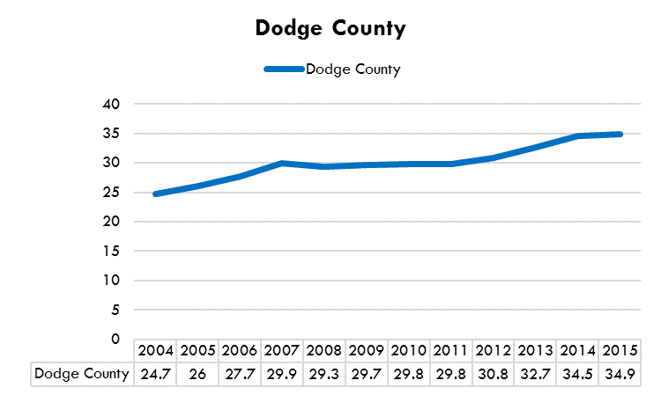 | 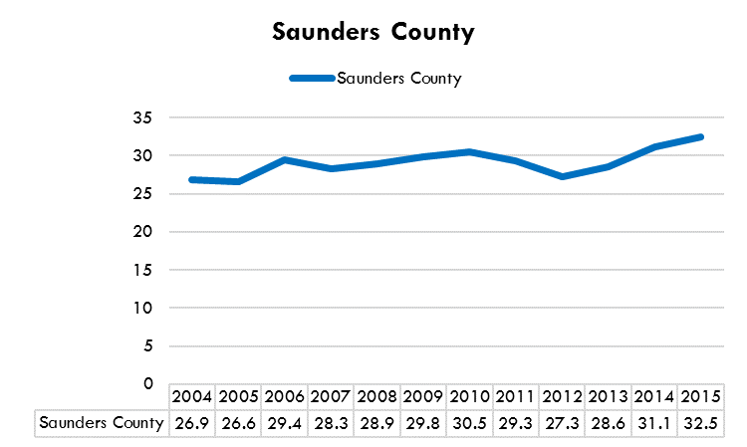
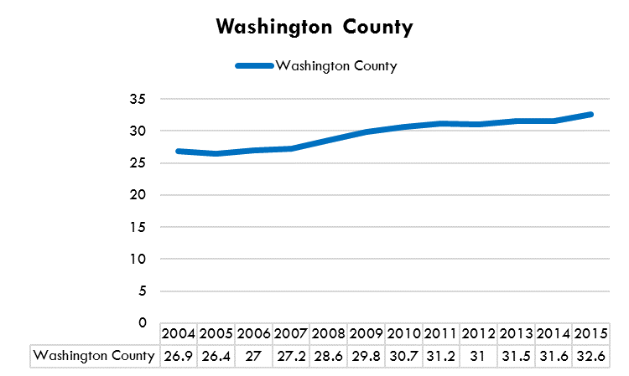
Source: CDC, Diabetes and Obesity Data Indicators, 2004-2015

Health Screening

In the most recent year of available data (either 2016 or 2017), 88.8 percent of adults in the Three Rivers District reported having their blood pressure checked in the past year, 87.1 percent reported having their cholesterol checked in the past five years, and 70.7% reported being up to date on colon cancer screening. Each of these indicators was higher than the State (Figures 107 through 109).

Figure 107: Had blood pressure checked in the past year among adults 18 and over (2017)
Three Rivers | 88.8%
Nebraska | 86.3%
Source: Behavioral Risk Factors Surveillance System (2017)

*Statistically significant difference between Three Rivers and the State. Source: Behavioral Risk Factors Surveillance System (2017)

Source: Behavioral Risk Factors Surveillance System (2017)
In 2016, 78.0 percent of women age 50 to 74 years old in the Three Rivers District reported being up to date on breast cancer screening (Figure 110). In 2016, 78.5 percent of women age 21 to 65 years old in the Three Rivers District reported being up to date on cervical cancer screening (Figure 111).

Source: Behavioral Risk Factors Surveillance System (2017)

Source: Behavioral Risk Factors Surveillance System (2017)

General Health Metrics

County Health Rankings provides health outcomes rankings at the county-level for every State in the country. There are two primary sub-categories that comprise the health outcomes ranking: length of life and quality of life. The county that is ranked first is considered the healthiest county in the State. Washington County has consistently had high rankings on this metric, followed by Saunders and Dodge Counties in ranking (Figure 112).

Figure 112: HEALTH OUTCOMES (length and quality of life) County Health Rankings
 | 2012  (out of 79) | 2013  (out of 79) | 2014  (out of 79) | 2015  (out of 78) | 2016  (out of 78) | 2017  (out of 78) | 2018  (out of 80) | 2019  (out of 79)
Dodge County | 60 | 45 | 47 | 50 | 47 | 58 | 71 | 72
Saunders County | 43 | 34 | 36 | 42 | 14 | 12 | 10 | 14
Washington County | 3 | 7 | 8 | 6 | 5 | 3 | 8 | 6
Source: County Health Rankings (2019)

County Health Rankings also provides health factors rankings at the county-level for every State in the country. The sub-categories that comprise the health factors rankings include health behaviors, clinical care, social & economic factors, and physical environment. Washington County has also consistently had high rankings on this metric, followed by Saunders and Dodge Counties in ranking (Figure 113).

Figure 113: HEALTH FACTORS (health behaviors, clinical care, social and economic factors, and the physical environment) County Health Rankings
 | 2012  (out of 79) | 2013  (out of 79) | 2014  (out of 79) | 2015  (out of 78) | 2016  (out of 78) | 2017  (out of 78) | 2018  (out of 80) | 2019 (out of 79)
Dodge County | 63 | 60 | 59 | 50 | 56 | 63 | 67 | 67
Saunders County | 20 | 25 | 21 | 33 | 20 | 18 | 17 | 18
Washington County | 9 | 9 | 5 | 10 | 4 | 12 | 4 | 4
Source: County Health Rankings (2019)

From 2015 to 2017, there were 470 premature deaths (a death of an individual under the age of 75) in Dodge County, 254 in Saunders County, and 197 in Washington County. Dodge and Saunders Counties have a high rate of years of potential lost per 100,000 population compared to the State for the 2008-2010 and 2010-2012 combined years, while only Dodge County has a higher rate of years of potential lost per 100,000 population when compared to the State for the 2013-2015 and 2015-2017 combined years (Figure 114).

Figure 114. Premature deaths (deaths under age 75) and years of potential life lost (YPLL) per 100,000 population (age-adjusted)
 | 2008-2010 |  | 2010-2012 |  | 2013-2015 |  | 2015-2017
 | Number of deaths under age 75 | YPLL | Number of deaths under age 75 | YPLL | Number of deaths under age 75 | YPLL | Number of deaths under age 75 | YPLL
Dodge County | 409 | 6,317 | 410 | 6,261 | 456 | 7,378 | 470 | 7,094
Saunders County | 223 | 6,236 | 234 | 6,169 | 248 | 5,459 | 254 | 6,008
Washington County | 174 | 4,819 | 170 | 4,844 | 194 | 4,879 | 197 | 4,726
Nebraska | 16,746 | 5,904 | 17,223 | 5,792 | 19,065 | 6,017 | 19,520 | 6,060
Source: National Center for Health Statistics, contained in County Health Rankings (2019)

In 2017, one-in-ten (9.5%) adults in the Three Rivers District reported that their physical health was not good on 14 or more of the past 30 days (Figure 115).

Source: Behavioral Risk Factors Surveillance System (2017)

Cancer

Overall, the Three Rivers District had a slightly higher rate of deaths due to cancer compared to the State over the five-year period of 2013 to 2017. From 2013 to 2017 there were 955 deaths due to cancer in the Three Rivers District. The leading cause of cancer mortality was lung cancer, accounting for 241 deaths (Figures 116 through 118).

Source: Nebraska DHHS, Vital Records (2017)

Figure 117: Number of deaths due to cancer (2013-2017)
 | Dodge County | Saunders County | Washington County | Three Rivers | Nebraska
Lung Cancer | 142 | 53 | 46 | 241 | 4,385
Female Breast Cancer | 32 | 12 | 17 | 61 | 1,212
Cervical Cancer | 5 | -* | 0 | 8 | 118
Colon Cancer | 45 | 17 | 27 | 89 | 1,652
Prostate Cancer | 24 | 13 | 11 | 48 | 854
Melanoma | 7 | -* | -* | 14 | 287
Oral Cancer | -* | -* | 0 | 7 | 251
All other types of cancer | 252 | 135 | 117 | 487 | 8,642
All types of cancer | 507 | 230 | 218 | 955 | 17,401
Source: Nebraska DHHS, Vital Records (2017)

Figure 118: Percentage of deaths due to cancer by age (2013-2017)
 | 1-14 | 15-24 | 25-44 | 45-64 | 65 and over
Three Rivers | 0.0% | 0.0% | 2.1% | 24.6% | 73.3%
Nebraska | 0.2% | 0.3% | 2.4% | 24.4% | 72.7%
Source: Nebraska DHHS, Vital Records (2017)

Rates of mortalities due to various types of cancer are presented in Figures 119 through 124.

Source: Nebraska DHHS, Vital Records (2017)

Source: Nebraska DHHS, Vital Records (2017)

Numbers of deaths due to cervical cancer are too small to present rates in Saunders and Washington counties. Cervical cancer death rate per 100,000 population was 5.2 for Dodge County in the 2013-2017 combined years, 2.5 times higher when compared to the State rate (2.1 deaths per 100,000 population).

.
Source: Nebraska DHHS, Vital Records (2017)

Source: Nebraska DHHS, Vital Records (2017)

Source: Nebraska DHHS, Vital Records (2017)

*Numbers are suppressed due to small number of deaths. Source: Nebraska DHHS, Vital Records (2017)

In 2017, 7.4 percent of Three Rivers adults reported ever being told that they have cancer other than skin cancer (compared to 6.6% for the State) and 10.8 percent reported ever being told they have cancer in any form (compared to 11.0% for the State). In 2014, there was a statistically significant difference between the Three Rivers and the State on both of these indicators (Figures 125 and 126).

*Statistically significant difference between Three Rivers and the State. Source: Behavioral Risk Factors Surveillance System (2017)

*Statistically significant difference between Three Rivers and the State. Source: Behavioral Risk Factors Surveillance System (2017)

Heart Disease

As a whole the Three Rivers District has a lower rate of deaths due to Heart Disease compared to the State. However, Saunders and Washington Counties have a higher rate than the State in the 2013-2017 combined years. From 2013 to 2017 there were 826 deaths due to Heart Disease in the Three Rivers District (Figures 127 through 129).

Source: Nebraska DHHS, Vital Records (2017)

Figure 128: Number of deaths and death rates per 100,000 population due to heart disease (2013-2017)
Dodge County | Saunders County | Washington County | Three Rivers | Nebraska
412 (137.5) | 227 (154.8) | 187 (149.9) | 826 (144.2) | 17,151 (147.4)
Source: Nebraska DHHS, Vital Records (2017)

Figure 129: Percentage of deaths due to coronary heart disease by age (2013-2017)
 | 1-14 | 15-24 | 25-44 | 45-64 | 65 and over
Three Rivers | 0.0% | 0.0% | 1.6% | 9.3% | 88.7%
Nebraska | 0.1% | 0.1% | 1.6% | 13.8% | 84.4%
Source: Nebraska DHHS, Vital Records (2013)

In 2017, 4.7 percent of Three Rivers adults reported that they have ever been told by a medical professional that they had a heart attack or coronary heart disease, the lowest percentage since 2011 (Figure 130).

Source: Behavioral Risk Factors Surveillance System (2014)

Stroke

The rate of stroke-related deaths has steadily decreased in the Three Rivers District when compared to the State. However, Saunders County increased the rate of stroke-related deaths in 2013-2017 combined years when compared to previous years. From 2013 to 2017, there were 192 stroke-related deaths in the Three Rivers District (Figures 131 through 133).

Source: Nebraska DHHS, Vital Records (2017)

Figure 132: Number of deaths and death rates per 100,000 population due to Stroke (2013-2017)
Dodge County | Saunders County | Washington County | Three Rivers | Nebraska
107 (36.2) | 48 (33.8) | 37 (28.7) | 192 (33.3) | 3,934 (40.7)
Source: Nebraska DHHS, Vital Records (2017)

Figure 133: Percentage of stroke-related death by age (2013-2017)
 | 1-14 | 15-24 | 25-44 | 45-64 | 65 and over
Three Rivers | 0.0% | 0.0% | 0.0% | 9.4% | 89.6%
Nebraska | 0.0% | 0.1% | 1.0% | 10.7% | 88.0%
Source: Nebraska DHHS, Vital Records (2017)

In 2017, 3.1 percent of Three Rivers adults reported that they have ever been told by a medical professional that they had a stroke (Figure 134).

Source: Behavioral Risk Factors Surveillance System (2017)

High Blood Pressure and Cholesterol

In 2017, 30.3 percent of Three Rivers adults reported that they have ever been told by a medical professional that they have high blood pressure and 33.5 percent reported that they have every been told that they have high cholesterol. (Figures 135 and 136).

*Statistically significant difference between Three Rivers and the State. Source: Behavioral Risk Factors Surveillance System (2017)

Source: Behavioral Risk Factors Surveillance System (2017)

Diabetes
As a whole, the Three Rivers District has a similar rate of diabetes-related deaths compared to the State. The Three Rivers District in the 2013-2017 combined years had a lower rate of diabetes-related deaths than the State for first time since 2007-2011 combined years. The rate of diabetes-related deaths in Washington County is lower when compared to the District at 18.8 per 100,000 population vs. 23.2 per 100,000, respectively. From 2013 to 2017, there were 129 diabetes-related deaths in the Three Rivers District (Figures 137 through 139).

Source: Nebraska DHHS, Vital Records (2017)

Figure 138: Number of diabetes-related deaths and death rates per 100,000 population (2013-2017)
Dodge County | Saunders County | Washington County | Three Rivers | Nebraska
69 (25.5) | 34 (23.7) | 26 (18.8) | 129 (23.2) | 2,572 (23.1)
Source: Nebraska DHHS, Vital Records (2017)

Figure 139: Percentage of diabetes-related deaths by age (2013-2017)
 | 1-14 | 15-24 | 25-44 | 45-64 | 65 and over
Three Rivers | 0.0% | 0.0% | 0.0% | 24.4% | 75.6%
Nebraska | 0.0% | 0.4% | 2.9% | 20.2% | 76.5%
Source: Nebraska DHHS, Vital Records (2017)

In 2017, 9.8 percent of Three Rivers adults reported that they have ever been told by a doctor that they have diabetes (Figure 140).

*Differences were statistically significant. Source: Behavioral Risk Factors Surveillance System (2017)

Respiratory and Pulmonary Illnesses

The rate of deaths due to Chronic Obstructive Pulmonary Disease (COPD) in the Three Rivers District has steadily increased from 43.2 deaths per 100,000 population in the 2007-2011 combined years to 53.2 deaths per 100,000 population in the 2013-2017 combined years, even higher when compared to the State level (49.2 deaths per 100,000 population). Death rates in Dodge County have been consistently higher when compared to the State. From 2013 to 2017, there were 299 deaths due to COPD in the Three Rivers District (Figures 141 and 142).

Source: Nebraska DHHS, Vital Records (2017)

Figure 142: Number of deaths due to Chronic Obstructive Pulmonary Disease (2013-2017)
Dodge County | Saunders County | Washington County | Three Rivers | Nebraska
171 | 68 | 60 | 299 | 5,491
Source: Nebraska DHHS, Vital Records (2017)

5.7 percent of adults reported that they have ever been told by a medical professional that they have COPD (Figure 143).

Source: Behavioral Risk Factors Surveillance System (2017)

The rate of deaths due to Chronic Lung Disease is higher in the Three Rivers District when compared to the State, with Dodge County having the highest rates in the District. There were 282 deaths due to Chronic Lung Disease in the Three Rivers District from 2013 to 2017 (Figures 144 and 145).

Source: Nebraska DHHS, Vital Records (2017)

Figure 145: Number of deaths due to chronic lung disease (2013-2017)
Dodge County | Saunders County | Washington County | Three Rivers | Nebraska
160 | 66 | 56 | 282 | 5,242
Source: Nebraska DHHS, Vital Records (2017)

Nearly 9 percent of adults in the Three Rivers District reported that they have been told by a medical professional that they currently have Asthma in 2017 (Figure 146). The incidence of asthma reported by adults in the District has steadily increased since 2015, and in the years 2016 and 2017 have been higher when compared to the State incidence rates.

Source: Behavioral Risk Factors Surveillance System (2017)

Child and Adolescent Mortality

The death rate among ages 1 to 14 and 15 to 24 is higher in the Three Rivers District when compared to the State. There were 62 deaths for individuals age 1 to 24 in the Three Rivers District from 2013 to 2017 (Figures 147 and 148).

Results from the Three Rivers District were based on age-group population estimates from 2013 through 2017 (American Community Survey). Source: Nebraska DHHS, Vital Records (2017).

Figure 148: Number of deaths among ages 1 to 14 and 15 to 24 (2013-2017)
 | Three Rivers |  | Nebraska
 | 1 to 14 | 15 to 24 | 1 to 14 | 15 to 24
Deaths by age group | 17 | 45 | 301 | 838
Total Deaths 1 to 24 | 62 |  | 1,139
Source: Nebraska DHHS, Vital Records (2017)

Maternal and Infant Health

For 2013-2017 combined years, 65.9 percent of births in the Three Rivers District received prenatal care beginning in the first trimester compared to 72.9 percent at the State level (Figure 149). The percentage of infants born to a woman receiving prenatal care has steadily decreased in the District since 2007-2011 combined years.

Source: Nebraska DHHS, Vital Records (2017)

Washington County has the highest percentage of infants born to a woman receiving prenatal care beginning in the first trimester (78.3%), followed by Saunders County (76.9%), and then by Dodge County (55.1%). Figure 150.

Source: Nebraska DHHS, Vital Records (2017)

The rate of children born with low birth weight (less than 2,500 grams or approximately 5.5 pounds) has been consistently lower for each county in the Three Rivers District as compared to the State since 2006-2010 combined years (Figure 151). However, Dodge County for the 2013-2017 combined years showed a higher rate of children born with low birth weights when compared to State (71.4 per 1,000 births vs. 69.5 per 1,000 births, respectively).

Figure 151. Number of low birth weights* and rate per 1,000 births
 | 2006-2010 | 2007-2011 | 2008-2012 | 2009-2013 | 2013-2017
Dodge County | 170 (68.3) | 150 (62.1) | 139 (57.0) | 134 (55.9) | 177 (71.4)
Saunders County | 77 (59.0) | 77 (58.4) | 76 (59.0) | 68 (53.6) | 80 (66.0)
Washington County | 62 (57.4) | 65 (61.4) | 56 (54.8) | 58 (55.6) | 76 (68.7)
Three Rivers | 309 (63.3) | 292 (60.9) | 271 (57.1) | 260 (55.2) | 333 (69.4)
Nebraska | 9,479 (71.0) | 9,276 (70.0) | 9,118 (69.3) | 8,899 (68.1) | 9,176 (69.5)
*Less than 2,500 grams (~5.5 pounds). Source: Nebraska DHHS, Vital Records (2017)

From 2006-2010 combined years to 2009-2013 combined years, the rate of premature births has been slightly lower in the Three Rivers District compared to the State. However, for the 2013-2017 combined years, the percentage of premature births in the District was higher when compared to the State (10.6% vs. 9.8%, respectively) (Figure 152).

Figure 152. Number of premature births* with percentage of total births
 | 2006-2010 | 2007-2011 | 2008-2012 | 2009-2013 | 2013-2017
Dodge County | 260 (10.4%) | 226 (9.4%) | 218 (8.9%) | 211 (8.8%) | 277 (11.2%)
Saunders County | 114 (8.7%) | 116 (8.8%) | 124 (9.6%) | 123 (9.7%) | 114 (9.4%)
Washington County | 101 (9.4%) | 97 (9.2%) | 79 (7.7%) | 73 (7.0%) | 119 (10.7%)
Three Rivers | 475 (9.8%) | 439 (9.2%) | 421 (8.8%) | 407 (8.6%) | 510 (10.6%)
Nebraska | 13,020 (9.8%) | 12,681 (9.6%) | 12,522 (9.5%) | 12,202 (9.3%) | 12,979 (9.8%)
*Premature births are live births with less than 37 weeks of gestation. Gestational age was determined by ultrasound. Source: Nebraska DHHS, Vital Records (2017)

The rate of birth defects has been consistently higher in the Three Rivers District compared to the State. During the five-year period of 2012 to 2016, each county in the district had a rate of birth defects that was higher than the State. There were 457 children born with birth defects during this period in the district (Figure 153).

Figure 153. Number of cases of birth defects with percentage of total births
 | 2006-2010 | 2007-2011 | 2008-2012 | 2009-2013 | 2012-2016
Dodge County | 141 (5.6%) | 142 (5.9%) | 148 (6.0%) | 164 (6.8%) | 228 (9.0%)
Saunders County | 55 (4.2%) | 62 (4.7%) | 71 (5.5%) | 92 (7.2%) | 129 (10.8%)
Washington County | 68 (6.3%) | 84 (7.9%) | 77 (7.5%) | 80 (7.7%) | 100 (9.3%)
Three Rivers | 264 (5.4%) | 288 (6.0%) | 296 (6.2%) | 336 (7.0%) | 457 (9.5%)
Nebraska | 5,970 (4.4%) | 7,279 (5.5%) | 7,439 (5.6%) | 7,883 (6.0%) | 10,463 (7.9%)
Source: Nebraska DHHS, Vital Records (2016)
The rate of infant deaths has been consistently lower in the Three Rivers District compared to the State. There were 19 infant deaths from 2013 to 2017 in the District (Figure 154).

Figure 154. Number of infant deaths with rate* per 1,000 births
 | 2006-2010 | 2007-2011 | 2008-2012 | 2009-2013 | 2013-2017
Dodge County | 13 (5.2) | 11 (4.6) | 11 (4.5) | 12 (5.0) | 10 (4.0)
Saunders County | 4 (3.1) | 5 (3.8) | 5 (3.9) | 6 (4.7) | 5 (4.1)
Washington County | 3 (2.8) | 4 (3.8) | 4 (3.9) | 4 (3.8) | **
Three Rivers | 20 (4.1) | 20 (4.2) | 20 (4.2) | 22 (4.2) | 19 (4.0)
Nebraska | 758 (5.7) | 753 (5.7) | 690 (5.2) | 683 (5.2) | 739 (5.6)
*Rates based on small numbers may not be reliable. **Number of births/events and rate suppressed due to a small number of cases (i.e., fewer than 5). Source: Nebraska DHHS, Vital Records (2017)

Teen Pregnancy

Dodge County has consistently had a higher percentage of births to teen mothers (age 19 and under) as compared to the State, though the rate does appear to be on the decline. From 2012 to 2016, there were 249 births to teen mothers across the Three Rivers District, 171 of which were to mothers from Dodge County (Figure 155).

Figure 155. Number and percentage of births to teen mothers*
 | 2006-2010 | 2007-2011 | 2008-2012 | 2009-2013 | 2012-2016
Dodge County | 244 (9.8%) | 254 (10.5%) | 231 (9.5%) | 207 (8.6%) | 171 (6.8%)
Saunders County | 50 (3.8%) | 45 (3.4%) | 47 (3.6%) | 45 (3.5%) | 36 (3.0%)
Washington County | 55 (5.1%) | 50 (4.7%) | 49 (4.8%) | 46 (4.4%) | 42 (3.9%)
Three Rivers | 349 (7.1%) | 349 (7.3%) | 327 (6.9%) | 298 (6.8%) | 249 (5.2%)
Nebraska | 10,968 (8.2%) | 10,570 (8.0%) | 9,955 (7.6%) | 9,208 (7.1%) | 7,287 (5.5%)
*Mothers age 19 and under. Source: Nebraska DHHS, Vital Records (2016)

Sexually Transmitted Disease

Approximately one-in-four adults reported that they have ever been tested for HIV in the Three Rivers District in 2017. This rate is notably lower than the rate for the State (Figure 156).

*Statistically significant difference between Three Rivers and the State. Source: Behavioral Risk Factors Surveillance System (2017)

The incidence of HIV is relatively low in the Three Rivers District. In 2015, there were six cases in Dodge County, and none in Saunders and Washington counties. Overall, there were eight HIV cases in the Three Rivers District from 2013 to 2017. (Division of Public Health, NE DHHS, 2019).

Rates of Chlamydia per 100,000 population have been consistently lower in the Three Rivers District when compared to the State. Except for Dodge County in 2015, all counties in the District had lower rates of Chlamydia when compared to the State from 2010 to 2018. However, the number and rate of cases of Chlamydia have generally been increasing across the Three Rivers district, as is the case for the entire state, since 2010 (Figure 157).

Figure 157. Number and rate of newly diagnosed Chlamydia cases per 100,000 by year
 | 2010 | 2011 | 2012 | 2013 | 2014 | 2015 | 2016 | 2017 |  | 2018
Dodge County | 85 (231.7) | 78 (212.1) | 107 (293.7) | 125 (343.2) | 119 (325.9) | 157 (427.3) | 126 (343.3) | 164 (446.8) |  | 125 (339.8)
Saunders County | 14 (67.4) | 22 (105.4) | 34 (163.3) | 40 (192.1) | 39 (186.3) | 46 (219.9) | 37 (176.1) | 34  (161.5) |  | 39  (183.1)
Washington County | 33 (163.1) | 23 (113.3) | 27 (133.3) | 48 (237.0) | 43 (212.6) | 30 (148.1) | 53 (261.8) | 41  (197.9) |  | 43  (208.1)
Three Rivers | 132 (169.9) | 123 (157.8) | 168 (216.8) | 213 (275.8) | 201 (259.7) | 233 (300.9) | 216 (277.4) | 239 (304.5) |  | 207 (262.8)
Nebraska | 5,113 (280.0) | 6,780 (368.0) | 6,748 (363.7) | 7,301 (393.5) | 7,499 (401.3) | 7,956 (422.9) | 8,197 (432.3) | 8637 (449.8) |  | 8093 (432.9)
Sources: National Center for HIV/AIDS, Viral Hepatitis, STD, and TB Prevention, contained in County Health Rankings, 2019
Nebraska Department of Health and Human Services, Infectious Diseases Prevention Unit, Division of Public Health (2019)
From 2011 to 2018, rates of Gonorrhea have been substantially lower for all three counties in the Three Rivers District compared to the state. As with Chlamydia, the number and rate of Gonorrhea cases has been generally increasing since 2011 (Figure 158).

Figure 158. Number and rate of newly diagnosed Gonorrhea cases per 100,000 by year
 | 2011 | 2012 | 2013 | 2014 | 2015 | 2016 | 2017 | 2018
Dodge County | 8 (21.6) | 8 (21.8) | 16 (43.7) | 9 (24.5) | 18 (49.0) | 11 (29.9) | 25 (68.1) | 13 (35.3)
Saunders County | 0 (0) | 0 (0) | 3 (14.4) | 5 (23.9) | 6 (28.5) | 6 (28.5) | 11 (52.2) | 10 (46.9)
Washington County | 6 (29.6) | 9 (44.4) | 7 (34.6) | 6 (29.6) | 3 (14.8) | 10 (48.5) | 7 (33.8) | 5 (24.2)
Three Rivers | 14 (17.9) | 17 (21.9) | 26 (33.4) | 20 (25.7) | 27 (34.7) | 27 (34.4) | 43 (54.8) | 28 (35.5)
Nebraska | 1341 (72.8) | 1426 (76.9) | 1387 (74.2) | 1476 (78.4) | 1673 (88.2) | 2161 (113.3) | 2669 (139.0) | 2725 (141.2)

Alzheimer’s Disease

The rate of Alzheimer’s Disease-related death is basically comparable between the Three Rivers District and the State. However, the rate of Alzheimer’s-related deaths in Washington County is notably higher than in the State. Note that these rates, as well as all of the other mortality rates are age adjusted, and therefore the higher percentage of elderly individuals in Washington County (and the rest of the district) does not impact the rates. There were 155 Alzheimer’s Disease-related deaths in the Three Rivers District from 2013 to 2017 (Figures 159 through 161).

Source: Nebraska DHHS, Vital Records (2017)

Figure 160. Number of Alzheimer’s Disease-related deaths (2013-2017)
Dodge County | Saunders County | Washington County | Three Rivers | Nebraska
82 | 12 | 61 | 155 | 3,001
Source: Nebraska DHHS, Vital Records (2017)

Figure 161. Percentage of Alzheimer’s Disease-related deaths by age (2013-2017)
 | 1-14 | 15-24 | 25-44 | 45-64 | 65 and over
Three Rivers | 0.0% | 0.0% | 0.0% | 0.0% | 98.1%*
Nebraska | 0.0% | 0.0% | 0.0% | 1.0% | 99.0%
Percentages do not add 100% as number of deaths for age groups 1-14 to 45-64 are suppressed due to small number of cases. Source: Nebraska DHHS, Vital Records (2017)

Arthritis

In 2017, 27.5 percent of adults in the Three Rivers reported that they have ever been told by a medical professional that they have arthritis (compared to 24.0% for the State) (Figure 162). Note that this rate, as well as all of the other BRFSS data, is age-adjusted, and therefore if there was a higher percentage of elderly individuals in the Three Rivers survey sample, it would not have an impact on the rate.

*Statistically significant difference between Three Rivers and the State. Source: Behavioral Risk Factors Surveillance System (2017)

Oral Health

In 2017, approximately two-thirds (68.7%) of adults in the Three Rivers District reported that they have visited a dentist or dental clinic in the past year (Figure 163).

Source: Behavioral Risk Factors Surveillance System (2017)

In 2016, 45.5 percent of Three Rivers adults age 45 to 64 reported that they have had permanent teeth extracted due to tooth decay or gum disease (compared to 45.1% for the State) and 13.0 percent of Three Rivers adults age 65 and reported having all of their permanent teeth extracted due to tooth decay or gum disease (Figure 164).

Figure 164. Dental health indicators among adults 18 and over (2016)
 | Three Rivers | Nebraska
Had any permanent teeth extracted due to tooth decay or gum disease among 45-64 year olds | 45.5% | 45.1%
Had all permanent teeth extracted due to tooth decay or gum disease among adults 65 and over | 13.0% | 13.2%
Had all permanent teeth extracted due to tooth decay or gum disease among 65-74 year olds | 11.6% | 10.4%
Source: Behavioral Risk Factors Surveillance System (2017)

Kidney Disease

In 2017, 2.6 percent of Three Rivers adults reported that they have ever been told by a medical professional that they have a kidney disease (Figure 165).

Source: Behavioral Risk Factors Surveillance System (2017)

Flu and Pneumonia Vaccination

Among those 18 and over in the Three Rivers District, 47.4 percent reported having a flu vaccination in the past year in 2017 (Figure 166).

Source: Behavioral Risk Factors Surveillance System (2017)

Among those 65 and over in the Three Rivers District, 63.2% reported having a flu vaccination in the past year in 2017 (Figure 167).

Source: Behavioral Risk Factors Surveillance System (2017)

In 2017 among those 65 and over in the Three Rivers District, 74.9 percent reported ever having a pneumonia vaccination (Figure 168).

Source: Behavioral Risk Factors Surveillance System (2017)

Child Immunization

Figures 169 through 171 display immunization data for Kindergarten, seventh grade, and out-of-State transfer students. Immunization rates are relatively high in the Three Rivers District, being for the most part comparable to the State.

Figure 169. Kindergarten students immunized* for the 2018-2019 school year (number and percentage)
 | Dodge | Saunders | Washington | Three Rivers | Nebraska
DTaP/DTP/DT/Td (more than 3 doses) | 401 (97.1%) | 271 (98.5%) | 245 (96.5%) | 917 (97.3%) | 27,850 (97.4%)
Polio  (more than 3 doses) | 405 (98.1%) | 268 (97.5%) | 245 (96.5%) | 918 (97.5%) | 25,948 (97.7%)
MMR  (2 doses) | 398 (96.4%) | 269 (97.8%) | 245 (96.5%) | 912 (96.8%) | 25,735 (96.9%)
Hepatitis B  (3 doses) | 404 (97.8%) | 268 (97.5%) | 247 (97.2%) | 919 (97.6%) | 25,874 (97.5%)
Varicella  (2 doses) | 392 (94.9%) | 268 (97.5%) | 246 (96.9%) | 906 (96.2%) | 25,466 (95.9%)
*Those receiving medical, religious, or provisional/military exemptions are counted as not being immunized. There were 16 religious exemptions, and 13 provisional/military exemptions among Three Rivers Kindergarten students. Source: Three Rivers Public Health Department. School Immunization Survey, 2018.

Figure 170. Seventh grade students immunized* for the 2018-2019 school year (number and percentage)
 | Dodge | Saunders | Washington | Three Rivers | Nebraska
Tdap  (1 dose) | 449 (98.0%) | 261 (95.3%) | 287 (97.0%) | 997 (97.0%) | 25,209 (96.5%)
MMR  (2 doses) | 452 (98.7%) | 268 (97.8%) | 289 (97.6%) | 1,009 (98.2%) | 25,733 (98.5%)
Hep B  (3 doses) | 452 (98.7%) | 270 (98.5%) | 293 (99.0%) | 1,015 (98.7%) | 25,757 (98.6%)
Varicella  (2 doses) | 447 (97.6%) | 269 (98.2%) | 290 (98.0%) | 1006 (97.9%) | 25,355 (97.1%)
*Those receiving medical, religious, or provisional/military exemptions are counted as not being immunized. There were 18 religious exemptions, and eight provisional/military exemptions among Three Rivers 7th grade students. Source: Three Rivers Public Health Department. School Immunization Survey, 2018.

Figure 171. Out-of-State transfer students immunized* for the 2018-2019 school year (number and percentage)
 | Dodge | Saunders | Washington | Three Rivers | Nebraska
MMR  (2 doses) | 71 (93.4%) | 21 (95.5%) | 38 (97.4%) | 130 (94.9%) | 6,176 (93.9%)
Hep B  (3 doses) | 61 (80.3%) | 21 (95.5%) | 37 (94.9%) | 119 (86.9%) | 6,071 (92.3%)
Varicella  (2 doses) | 61 (80.3%) | 21 (95.5%) | 35 (89.7%) | 117 (85.4%) | 5,810 (88.4%)
*Those receiving medical, religious, or provisional/military exemptions are counted as not being immunized. There were 15 provisional/military exemptions among Three Rivers out-of-State transfer students. Source: Three Rivers Public Health Department. School Immunization Survey, 2018.

Environmental Health

Housing Environment: Severe housing problems
“Poor housing conditions are associated with a wide range of health conditions, including respiratory infections, asthma, lead poisoning, injuries, and mental health.” (Krieger and Higgins, 2002).
Severe housing problems are classified as households with at least 1 of 4 housing problems: The four severe housing problems are: 1) incomplete kitchen facilities, 2) incomplete plumbing facilities, 3) more than 1.5 persons per room, and 4) cost burden greater than 50%.
It was estimated that 18 percent of households in the United States, 12.9 percent of households in Nebraska, and 9.6 percent in the Three Rivers District, which equals to 3,302 housing units, were classified as having “severe housing problems” (Comprehensive Housing Affordability Strategy (CHAS) data, 2011-2015). Saunders County had the highest percentage of severe housing problems (9.9%), followed by Dodge County (9.6%), and then by Washington County (9.2%). All counties in the Three Rivers Districts had lower percentages of severe housing problems when compared to the State (12.9%). Figure 172.

Source: Comprehensive Housing Affordability Strategy (CHAS) data, 2011-2015. https://www.huduser.gov/portal/datasets/cp.html

Air pollution - particulate matter (Annual Average PM_{2.5})

According to the Environmental Public Health Tracking Network from the CDC (https://ephtracking.cdc.gov), the 2014 annual average density of fine particulate matter in micrograms per cubic meter (PM2.5) in the Three Rivers District was higher when compared to the State of Nebraska (9.0 vs. 7.5, respectively). Saunders County had the highest annual average of fine particulate concentration in micrograms per cubic meter (9.1), followed by Dodge County (9.0), and then by Washington County (8.8). The three counties of the Three Rivers District have the highest annual average concentration of fine particulate matter in the State: Saunders County is ranked #7, Dodge County #8, and Washington County is ranked #14. Douglas and Sarpy counties have the highest concentrations of fine particulate matter in micrograms per cubic meter in the State (9.5 each). Figure 173 shows air pollution by county in the State of Nebraska.

Figure 173. Air pollution by county in Nebraska (2014)
Source: Centers for Disease Control and Prevention. Environmental Public Health Tracking Network. Annual PM 2.5 Level (Monitor + Modeled). Accessed From: https://ephtracking.cdc.gov/DataExplorer. Accessed on 06/23/2019

Risk-Screening Environmental Indicators

“Risk-Screening Environmental Indicators (RSEI) is a screening-level model to analyze factors that contribute to human health risk. These factors include amount of chemical released, degree of toxicity, and size of the exposed population. RSEI calculates scores to highlight releases that would potentially pose greater risk over a lifetime of exposure.” Please note that “RSEI Score - risk-related results combine surrogate dose with toxicity weight and population estimate, producing a unit-less value or score. Risk-related results are not independently meaningful and should only be used comparatively in relation to other model results.” (EPA, 2019; https://enviro.epa.gov/enviro/rsei.html?facid=68025RCHRD130NB).

RSEI Score Comparison from the Environmental Protection Agency (EPA) website from 2008 to 2017, shows that Washington County had a higher RSEI when compared to Dodge and Saunders Counties, but was slightly lower when compared to the State from 2013 to 2017. Saunders County had the lowest RSEI among all counties in the Three Rivers District, scoring “zero” RSEIs from 2008 to 2017 but in 2014 the RSEI score was 4. Figure 174 depicts RSEI scores by county, with comparisons to the State of Nebraska and the U.S.

Figure 174. RSEI Scores by Three Rivers District Counties, Nebraska and the U.S. 2008-2017
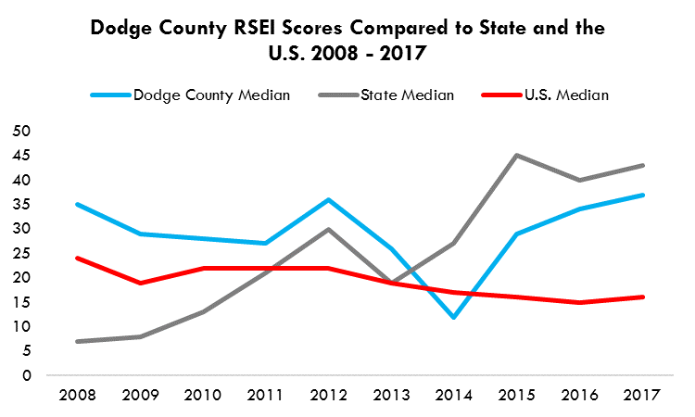 | 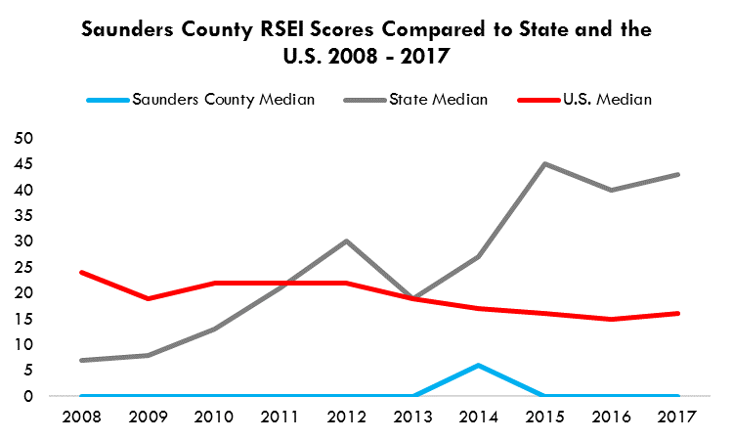
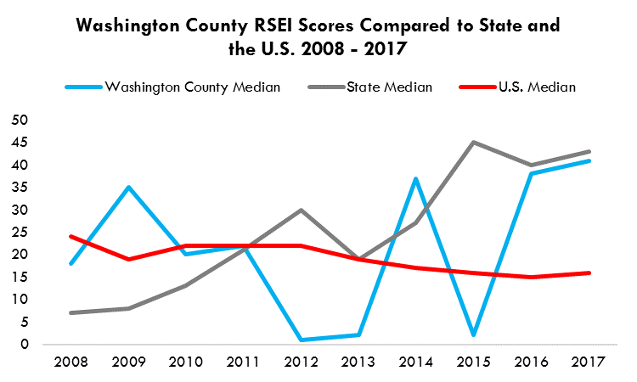 | 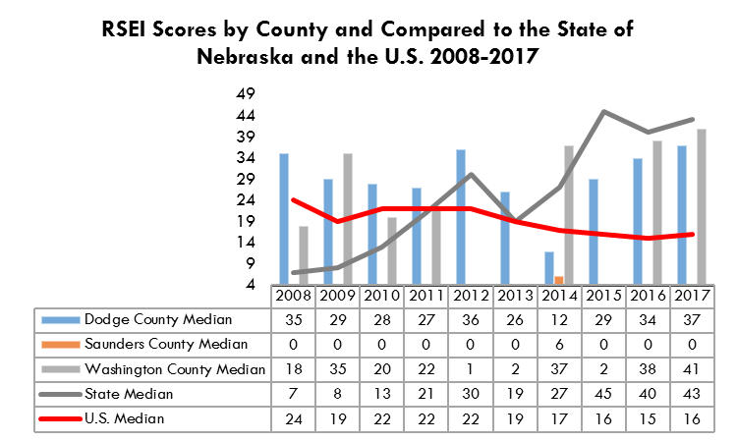
Source: U.S. Environmental Protection Agency (EPA). (https://enviro.epa.gov). Toxics Release Inventory (TRI) reports.

Drinking Water Violations
In 2018, there were 116 drinking water violations in Dodge County, far surpassing the Nebraska average per county of 7.8. Prior to 2018, Dodge County had a relatively small number of drinking water violations. Over the past five years, Saunders County has had a higher number of drinking water violations compared to the county average in four years. In just one year over the past five, Washington County has had a higher number of drinking water violations than the county average (Figure 175).
Figure 175. Drinking water violations
 | 2014 | 2015 | 2016 | 2017 | 2018
Dodge County | 2 | 7 | 3 | 2 | 116
Saunders County | 29 | 22 | 6 | 13 | 7
Washington County | 1 | 10 | 2 | 0 | 6
Nebraska Average per County | 6.8 | 7.3 | 3.9 | 9.9 | 7.8
Source: Nebraska DHHS, Office of Water and Environmental Health (2018)

Conclusion: Community Health Needs

The following three tables (Figures 176-178) present indicators of community health need for Dodge, Saunders, and Washington Counties. All of these indicators are included in the report. The indicators of community health need were selected based largely upon comparison to State-level data. As indication of statistical significance was only available for BRFSS data, statistical significance was not used as a criterion for determining a community health need. The indicators are not presented in prioritized order.

Figure 176. Indicators of Community Health Needs for DODGE COUNTY
Indicator/Area of Community Health Need | Rationale for Selection
- Aging Population | - The median age in Dodge County is 39.1 (State comparison: 36.3).  - 18.6% of the Dodge County population is age 65 and over (State comparison: 14.7%).
- Educational Attainment | - In 2017, an estimated 89.2% of the 25 and over population in Dodge County had at least a high school diploma or equivalent (State comparison: 90.9%), and 19.0% of the Dodge County population age 25 and over had a Bachelor’s Degree (State comparison: 30.6%).
- Poverty | - Dodge County population in poverty increased from 10.7% in 2013 to 13.2% in 2017, while poverty at the State level decreased from 12.8% in 2013 to 12.0% in 2017.  - Poverty rates for single mother families in Dodge County are at 35.7%, compared to 7.3% for married couple families.  - The median household income in Dodge County is $51,748 (State comparison: $56,675).  - In 2017-2018, 51.4% of children were eligible for free and reduced lunch in Dodge County (State comparison: 40.9%).  - In 2016, 37.7% of children in Dodge County were enrolled in Medicaid or the Children’s Health Insurance Plan (CHIP) (State comparison: 31.0%).
- Veterans | - Poverty rates among veterans in Dodge County increased from 5.6% in 2013 to 8.8% in 2017.  - Poverty rates among veterans have steadily increased in the Three Rivers District, from 4.5% in 2013 to 7.4% in 2017, while poverty rates among veterans in the State have been stable, around 5.8% during the same time period.  - Disability rates among veterans have increased in Dodge County from 29.1% in 2013 to 33.2% in 2017 (State comparison: 29.4% in 2017)
- Births to Unmarried Mothers | - From 2013 to 2017 there were 1,095 births to unmarried mothers in Dodge County, accounting for 43.5% of all births (State comparison: 33.0%).
- Births to Teen Mothers | - From 2012 to 2016 there were 171 births to teen mothers in Dodge County, accounting for 6.8% of all births (State comparison: 5.5%).
- Child Abuse/Neglect and Children in Foster Care | - In 2017, there were 50 substantiated cases of child abuse and neglect in Dodge County, accounting for a rate of 5.2 per 1,000 (State comparison: 4.1 per 1,000).  - In 2018, there were 107 children in foster care in Dodge County, accounting for a rate of 11.1 per 1,000 (State comparison: 6.8 per 1,000).
- Access to Health Services | - In 2017, an estimated 5.8% of the Dodge County population under 18 was without health insurance (State comparison: 5.3%).  - In 2017, an estimated 13.3% of the Dodge County population under 65 was without health insurance (State comparison: 10.4%).
Indicator/Area of Community Health Need | Rationale for Selection – DODGE COUNTY (cont.’)
- Health Care Professionals | - In Dodge County, there are higher ratios of the population with access to primary care physicians, dentists, and mental health providers than compared to the State.
- Birth Defects | - From 2013 to 2017 there were 228 cases of birth defects in Dodge County, accounting for 9.0% of all births (State comparison: 7.9%).
- Premature Births | - From 2013 to 2017 there were 277 premature births in Dodge County, accounting for 11.2% of all births (State comparison: 9.8%).
- Cancer | - From 2013 to 2017 there were 507 deaths due to cancer in Dodge County, accounting for an age-adjusted rate of 194.9 per 100,000 population (State comparison: 157.4 per 100,000).
- Deaths due to Stroke | - From 2013 to 2017 there were 107 deaths due to Stroke in Dodge County, accounting for an age-adjusted rate of 36.2 per 100,000 population (State comparison: 40.7 per 100,000).
- Motor Vehicle Deaths | - From 2013 to 2017 there were 44 motor vehicle deaths in Dodge County, accounting for an age-adjusted rate of 25.0 per 100,000 population (State comparison: 12.8 per 100,000).
- Unintentional Injury Deaths | - From 2013 to 2017 there were 114 unintentional injury deaths in Dodge County, accounting for an age-adjusted rate of 51.0 per 100,000 population (State comparison: 37.5 per 100,000).
- Respiratory and Pulmonary Illnesses | - From 2013 to 2017 there were 171 deaths due to COPD in Dodge County, accounting for an age-adjusted rate of 61.4 per 100,000 population (State comparison: 49.0 per 100,000).  - From 2013 to 2017 there were 160 deaths due to Chronic Lung Disease in Dodge County, accounting for an age-adjusted rate of 57.8 per 100,000 population (State comparison: 46.7 per 100,000).
- Suicide | - From 2013 to 2017 there were 31suicides in Dodge County, accounting for an age-adjusted rate of 15.3 per 100,000 population (State comparison: 12.9 per 100,000).
- Youth Substance Use | - Youth alcohol use, marijuana, and vaping among 12th graders increased, while binge drinking and prescription drug use decreased.
- Binge Drinking among 19-25-Year-Olds | - In the Three Rivers Health District in 2018, 83.8% of young adults reported using alcohol in the past month, compared to 75.8% for the whole State. These percentages were slightly lower when compared to 2016 results.  - In the Three Rivers Health District in 2018, 32.6% of young adults reported binge drinking in the past month compared to 34.5% for the whole State. These percentages were also slightly lower when compared to 2016 results.
- Obesity/Overweight | - Obesity rates in Dodge County increased from 29.8% in 2011 to 34.9% in 2015.  - Dodge County experienced the highest percentage increase of change in obesity rates among all counties in the Three Rivers Health Department between 2011 and 2015 (5.1%), followed by Saunders County (3.2%), and then by Washington County (1.4%).  - In 2017, an estimated 33.2% of the entire Three Rivers District adult population was obese (State comparison: 32.8%), and 71.4% of the adult population was overweight or obese (State comparison: 69.0%). The percentage of adults who are obese and/or overweight has been increasing in the Three Rivers District.
- Air Pollution | - Dodge County is ranked #8 among all counties in the State of Nebraska with the highest concentration of fine particulate matter of 9.0 per cubic meter (State comparison: 7.5 per cubic meter).
- Drinking water | - In 2018, Dodge County had 116 drinking water violations, which is almost 15 times higher that Nebraska average of 7.8 violations per county.

Figure 177. Indicators of Community Health Needs for SAUNDERS COUNTY
Indicator/Area of Community Health Need | Rationale for Selection
- Aging Population | - The median age in Saunders County is 41.0 (State comparison: 36.3).  - 17.4% of the Saunders County population is age 65 and over (State comparison: 14.7%).
- Poverty | - The poverty rate in Saunders County increased from 8.0% in 2013 to 9.0% in 2017.  - Based on the 2013‐2017 poverty estimates for Saunders County, an estimated 1,860 persons of all ages were living in poverty.
- Poverty for Single Mothers | - Poverty rates for single mother families in Saunders County are at 33.5%, compared to 4.0% for married couple families.  - Poverty rates among single mother families in Saunders County increased from 29.0% in 2013 to 33.5% in 2017.
- Veterans | - Poverty rates among veterans in Saunders County increased from 3.2% in 2013 to 4.4% in 2017.  - Disability rates among veterans have increased in Saunders County from 27.6% in 2013 to 37.4% in 2017 (State comparison: 29.4% in 2017)
- Access to Health Services | - In 2017, an estimated 2.3% of the Saunders County population under 18 was without health insurance (State comparison: 5.3%).  - In 2017, an estimated 5.9% of the Saunders County population under 65 was without health insurance (State comparison: 10.4%).
- Health Care Professionals | - In Saunders County, there are higher ratios of the population with access to primary care physicians, dentists, and mental health providers than compared to the State.
- Access to Locations for Physical Activity | - An estimated 53.6% of the population in Saunders County has adequate access to locations for physical activity (State comparison: 83.5%).
- Birth Defects | - From 2013 to 2017 there were 129 cases of birth defects in Saunders County, accounting for 10.8% of all births (State comparison: 7.9%).
- Cancer | - From 2013 to 2017 there were 230 deaths due to cancer in Saunders County, accounting for an age-adjusted rate of 159.8 per 100,000 population (State comparison: 157.4 per 100,000).
- Diabetes | - From 2013 to 2017 there were 34 deaths due to diabetes in Saunders County, accounting for an age-adjusted rate of 23.7 per 100,000 population (State comparison: 23.1 per 100,000).  - In 2017, 9.8% of the Three Rivers District population reported that they have ever been told by a doctor that they have diabetes (State comparison: 10.1%).
- Motor Vehicle Deaths | - From 2013 to 2017 there were 20 motor vehicle deaths in Saunders County, accounting for an age-adjusted rate of 17.8 per 100,000 population (State comparison: 12.8 per 100,000).
- Suicide | - From 2013 to 2017 there were 17 suicides in Saunders County, accounting for an age-adjusted rate of 13.5 per 100,000 population (State comparison: 12.9 per 100,000).
- Youth Substance Use | - Youth alcohol use, marijuana, and vaping among 12th graders increased, while binge drinking and prescription drug use decreased.
- Binge Drinking among 19-25-Year-Olds | - In the Three Rivers Health District in 2018, 83.8% of young adults reported using alcohol in the past month, compared to 75.8% for the whole State. These percentages were slightly lower when compared to 2016 results.  - In the Three Rivers Health District in 2018, 32.6% of young adults reported binge drinking in the past month compared to 34.5% for the whole State. These percentages were also slightly lower when compared to 2016 results.

Indicator/Area of Community Health Need | Rationale for Selection – SAUNDERS COUNTY (cont.’)
- Obesity/Overweight | - Obesity rates in Saunders County increased from 29.3% in 2011 to 32.5% in 2015.  - In 2017, an estimated 33.2% of the entire Three Rivers District adult population was obese (State comparison: 32.8%), and 71.4% of the adult population was overweight or obese (State comparison: 69.0%). The percentage of adults who are obese and/or overweight has been increasing in the Three Rivers District.
- Air Pollution | - Saunders County is ranked #7 among all counties in the State of Nebraska with the highest concentration of fine particulate matter of 9.1 per cubic meter (State comparison: 7.5 per cubic meter).

Figure 178. Indicators of Community Health Needs for WASHINGTON COUNTY
Indicator/Area of Community Health Need | Rationale for Selection
- Aging Population | - The median age in Washington County is 41.2 (State comparison: 36.3).  - 16.6% of the Washington County population is age 65 and over (State comparison: 14.7%).
- Poverty | - The poverty rate in Washington County increased from 7.7% in 2013 to 9.8% in 2017.  - Based on the 2013‐2017 poverty estimates for Washington County, an estimated 1,959 persons of all ages were living in poverty.
- Poverty for Single Mothers | - Poverty rates for single mother families in Washington County are at 50.8%, compared to 3.3% for married couple families.  - Poverty rates among single mother families in Washington County increased from 26.9% in 2013 to 50.8% in 2017.
- Veterans | - Poverty rates among veterans in Washington County increased from 4.0% in 2013 to 8.0% in 2017.  - Poverty rates among veterans have steadily increased in the Three Rivers District, from 4.5% in 2013 to 7.4% in 2017, while poverty rates among veterans in the State have been stable, around 5.8% during the same time period.  - Disability rates among veterans have slightly decreased in Washington County from 30.1% in 2013 to 28.0% in 2017 (State comparison: 29.4% in 2017)
- Access to Health Services | - In 2017, an estimated 3.2% of the Washington County population under 18 was without health insurance (State comparison: 5.3%).  - In 2017, an estimated 6.7% of the Saunders County population under 65 was without health insurance (State comparison: 10.4%).
- Health Care Professionals | - In Washington County, there are higher ratios of the population with access to primary care physicians, dentists, and mental health providers than compared to the State.
- Access to Locations for Physical Activity | - An estimated 49.4% of the population in Washington County has adequate access to locations for physical activity (State comparison: 83.5%).
- Birth Defects | - From 2012 to 2016 there were 100 cases of birth defects in Washington County, accounting for 9.3% of all births (State comparison: 7.9%).
- Premature Births | - From 2013 to 2017 there were 119 premature births in Washington County, accounting for 10.7% of all births (State comparison: 9.8%).
- Deaths due to Coronary Heart Disease | - From 2013 to 2017 there were 187 deaths due to coronary heart disease in Washington County, accounting for an age-adjusted rate of 149.9 per 100,000 population (State comparison: 147.4 per 100,000).
- Diabetes | - From 2013 to 2017 there were 26 deaths due to diabetes in Washington County, accounting for an age-adjusted rate of 18.8 per 100,000 population (State comparison: 23.1 per 100,000).  - In 2017, 9.8% of the Three Rivers District population reported that they have ever been told by a doctor that they have diabetes (State comparison: 10.1%).
- Motor Vehicle Deaths | - From 2013 to 2017 there were 15 motor vehicle deaths in Washington County, accounting for an age-adjusted rate of 13.1 per 100,000 population (State comparison: 12.8 per 100,000).
- Deaths due to Alzheimer’s Disease | - From 2013 to 2017 there were 61 deaths due to Alzheimer’s Disease in Washington County, accounting for an age-adjusted rate of 47.6 per 100,000 population (State comparison: 25.1 per 100,000).
- Youth Substance Use | - Youth alcohol use, marijuana, and vaping among 12th graders increased, while binge drinking and prescription drug use decreased.

Indicator/Area of Community Health Need | Rationale for Selection – WASHINGTON COUNTY (cont.’)
- Binge Drinking among 19-25-Year-Olds | - In the Three Rivers Health District in 2018, 83.8% of young adults reported using alcohol in the past month, compared to 75.8% for the whole State. These percentages were slightly lower when compared to 2016 results.  - In the Three Rivers Health District in 2018, 32.6% of young adults reported binge drinking in the past month compared to 34.5% for the whole State. These percentages were also slightly lower when compared to 2016 results.
- Obesity/Overweight | - Obesity rates in Washington County increased from 31.2% in 2011 to 32.6% in 2015.  - In 2017, an estimated 33.2% of the entire Three Rivers District adult population was obese (State comparison: 32.8%), and 71.4% of the adult population was overweight or obese (State comparison: 69.0%). The percentage of adults who are obese and/or overweight has been increasing in the Three Rivers District.
- Mental Health | - From 2013 to 2017, there were 9 suicides in Washington County, accounting for a rate of 8.9 per 100,000 population (State comparison: 12.9); an increase from 7.4 from 2009-2013.
- Air Pollution | - Washington County is ranked #14 among all counties in the State of Nebraska with the highest concentration of fine particulate matter: 8.8 per cubic meter (State comparison: 7.5 per cubic meter).

References

Anderson, J. J., Gray, S. R., Iliodromity, S., Welch, P., MacKay, D. F., Celis-Morales, C. A., ... & Pell, J. P. (2019). Sugar-sweetened beverages intake associates with all-cause mortality independently of other dietary and lifestyle factors and obesity. Proceedings of the Nutrition Society, 78(OCE1).

Census data. American FactFinder U.S. Census Bureau.
https://factfinder.census.gov

Centers for Disease Control and Prevention. Environmental Public Health Tracking Network. Annual PM 2.5 Level (Monitor + Modeled). Accessed From: https://ephtracking.cdc.gov/DataExplorer. Accessed on 06/23/2019

Centers for Disease Control and Prevention. County Data Indicators. Obesity prevalence. Interactive map. https://www.cdc.gov/diabetes/data/countydata/countydataindicators.html

Center for Public Affairs Research, UNO (2015). Nebraska County Projections.

Economic Research Service. U.S. Department of Agriculture (USDA).
https://www.ers.usda.gov/data-products/county-level-data-sets/

Environmental Protection Agency (EPA). RSEI Scores. https://enviro.epa.gov/

Krieger, J., & Higgins, D. L. (2002). Housing and health: time again for public health action. American journal of public health, 92(5), 758-768.

Nebraska Center for Nursing (2018). 2018 Nebraska RN Survey Report. Nebraska Department of Health and Human Services. Licensure Unit. Nebraska Center for Nursing. 24 pages. Lincoln, Nebraska.

Nebraska DHHS, Division of Public Health (2017). Annual Report on Local Public Health in Nebraska. December 1, 2017. http://dhhs.ne.gov/Reports/Health%20Care%20Funding%20Act%20LB692%20Annual%20Report%20-%202017.pdf

Nebraska Department of Education (2017-2018). Graduation rates.
https://nep.education.ne.gov

Nebraska DHHS (2016). Statewide Health Needs Assessment.

Nebraska DHHS (2018). Nebraska 2016 Vital Statistics Report.

Nebraska DHHS (2018). Nebraska Behavioral Health Risk Factor Surveillance System (BRFSS). 2011-2017 Detailed Data Tables by Nebraska Local and District Public Health Department.

Nebraska Rural Health Advisory Commission’s (2018). Annual Report, December 2018. http://dhhs.ne.gov/publichealth/RuralHealth/Documents/2018%20Annual%20Report.pdf

US Department of Health and Human Services. (2018). Physical activity guidelines for Americans. 2nd Edition. 2018.
https://health.gov/paguidelines/second-edition/pdf/Physical_Activity_Guidelines_2nd_edition.pdf [accessed 2019-02-19]

U.S. Department of Housing and Urban Development (HUD). CHAS data (Comprehensive Housing Affordability Strategy). https://www.huduser.gov/portal/datasets/cp.html

U.S. Census Bureau (2018). Understanding and Using American Community Survey Data: What All Data Users Need to Know, U.S. Government Printing Office, Washington, DC, July 2018. Rural Health Information Hub. Rural Data Explorer.
https://www.ruralhealthinfo.org

The total unduplicated number of individuals enrolled in CHIP (i.e. funded under title XXI of the Social Security Act); plus, the total unduplicated number of individuals enrolled in Medicaid (i.e. funded under title XIX of the Social Security Act) who are children.
https://www.cdc.gov/diabetes/data/countydata/countydataindicators.html
Fine particulate matter (PM_{2.5}) is an air pollutant that is a concern for people's health when levels in air are high. PM_{2.5} are tiny particles in the air that reduce visibility and cause the air to appear hazy when levels are elevated.

